DMAP Azure Installation Manual

Version 7.8
Date: February 23, 2023

Newt Global Consulting
1300 W Walnut Hill Ln | Suite # 230 | Irving TX 75038
Phone: +1 972 887 3159 | Fax: +1 214 260 6051
Contents
1. Introduction 3
2. Overview of DMAP 3
3. Prerequisites 5
3.1 System Requirements 5
3.2 Prerequisites 5
4. Create Azure Container Registry (ACR) and Download DMAP Images 6
4.1 Create ACR for Database Migration 6
4.2 Create ACR for Application Migration 11
5. Installation Procedure 16
5.1 Install Docker 16
5.2 Pull DMAP Image from ACR 16
5.3 Setting up DB Master & Worker Node Containers 18
5.4 Setting up App Master & Worker Node Containers 20
6. Activating DMAP License 21
6.1 Registering DB Master Node Container 21
6.2 Registering DB Worker Node Containers 25
7. Worker Node Setup 25
7.1 Worker Node Options 27
7.2 Resync Worker Node 27
7.3 Replace VM 28
7.4 Update Password 28
8. Troubleshooting 28
8.1 Unable to Log In to DMAP 29
8.2 DMAP Login Page is Not Displayed 30
9. Support 30

Introduction
DMAP is installed as a Docker image that can be downloaded from Azure Marketplace in Azure Container Registry (ACR). This manual covers the installation procedure for configuring DMAP on Docker container running on Azure/on-premises VM or in user’s workstation/laptop.
In this document VM (Virtual Machine) refers to a cloud or on-premises server, VM or user’s laptop on which DMAP can be installed.

Overview of DMAP
DMAP will help you accelerate the database schema conversion process from Oracle to PostgreSQL through progressive automation of stored procedures, functions, SQL queries, business logic and custom schema constructs beyond the standard conversion tools provided by public cloud platforms.
Below is the Deployment Architecture of DMAP. DMAP is deployed as a Docker container from the image provided by Newt Global.
DMAP Deployment Architecture Diagram
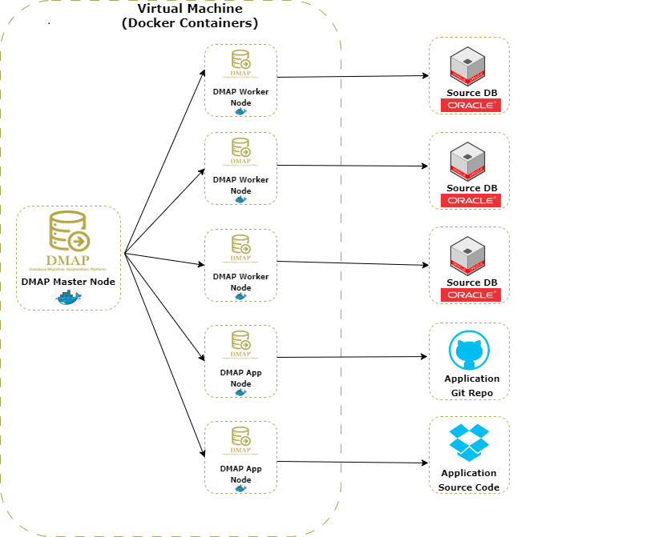
Source Oracle DB and target PostgreSQL DB are configured in DMAP application to run the automated conversion.
If you wish to run DMAP for performing assessment and conversion of few schemas only, then you shall setup only DB Master Node container.
Optionally, to perform assessment at scale, multiple DB Worker Node containers can be setup each running a separate instance of DMAP to run assessments of multiple databases in parallel in a short time. Both Master and worker node containers can be setup on same or different VM hosts. Assessments and conversions performed in Worker Node are periodically synced backed to Master node and displayed in Database Migration Life Cycle dashboard on DMA Master node.
Note: UI of DMAP is accessed through the URL of DB Master Container Node only. However, we need to register the DMAP license once for each DMAP DB Worker Node container by accessing its UI.

Prerequisites

3.1 System Requirements
The following hardware configuration is required for host VM (on-premises or cloud) in which DMAP is installed:
- 64-bit processor with Second Level Address Translation (SLAT)
- Recommended minimum system configuration:
  - Minimum 16 GB of RAM and 1 vCPU for Windows 10 or above OS for 1st DMAP container
  - Minimum 8 GB of RAM and 1 vCPU for Linux for 1st DMAP container
  - For each DMAP Master or Worker Node container, add additional 8 GB of RAM and 1 vCPU
  - 100 GB of free disk space in the main partition where DMAP is installed
- BIOS-level hardware virtualization support must be enabled in the BIOS settings
- For Windows platform, please install on Windows 10 or above and ensure that Hyper-V is enabled in Windows Features. You can search for “Turn Windows features on or off” in windows search box to enable it.

3.2 Prerequisites
DMAP is a standalone application (one user can access and work at a time) that runs in Docker based containers. Below are prerequisites to install DMAP:

- Admin/root access for VM to Install Docker and DMAP
- To use DMAP image from Azure Marketplace, following access is required:
  - Push DMAP Image to Azure Container Registry (ACR)
    - Azure Portal Account permission to create and access ACR for DMAP docker image
    - Access to push DMAP docker image from Azure Marketplace in the ACR
  - Pull DMAP Image from ACR in VM in which DMAP is to be installed
    - Access to Azure Container Registry (ACR) and permission to PULL images with roles that are assigned any one of the following:
Owner, Contributor, Reader, AcrPush, AcrPull
  - Install Azure CLI from https://docs.microsoft.com/en-us/cli/azure/install-azure-cli in the VM to pull the DMAP image from ACR

- Make sure VM on which DMAP will be installed is connected to internet. Below URL should be whitelisted and accessible from the Docker Container in which DMAP will be installed.
  - URL to download the DMAP backend and GUI services updates after DMAP container is started
Azure: https://msmkdmapdisks.blob.core.windows.net/
  - Licensing server which DMAP connects to check if user is authorized to run Assessment and Conversion
https://api.cryptlex.com/v3
- DMAP UI_PORT and PYTHON_SERVICE_PORT should be opened to allow DMAP UI to be accessed from a different VM or machine. Optionally, if App Master Container is installed then APP_PORT shall be opened as well.
- Use Google Chrome browser to access DMAP User Interface from DB Master Node container
- Read Only Access to Oracle Schemas to run Discovery and Assessment
- Oracle databases to be accessed shall be accessible from the VM in which DMAP is installed
- Read/Write Access to target PostgreSQL DB if user wants to run schema conversion to migrate schema from Oracle to PostgreSQL

Create Azure Container Registry (ACR) and Download DMAP Images

4.1 Create ACR for Database Migration
Create an Azure Container Registry to store the DMAP DB Migration image from Azure Marketplace which will be used to install DMAP DB Migration in the VM. To create Azure Container Registry for DMAP DB Migration, Login to Azure portal and go to Azure Marketplace. Search for “DMAP Oracle to Azure PostgreSQL Migration” as shown below.

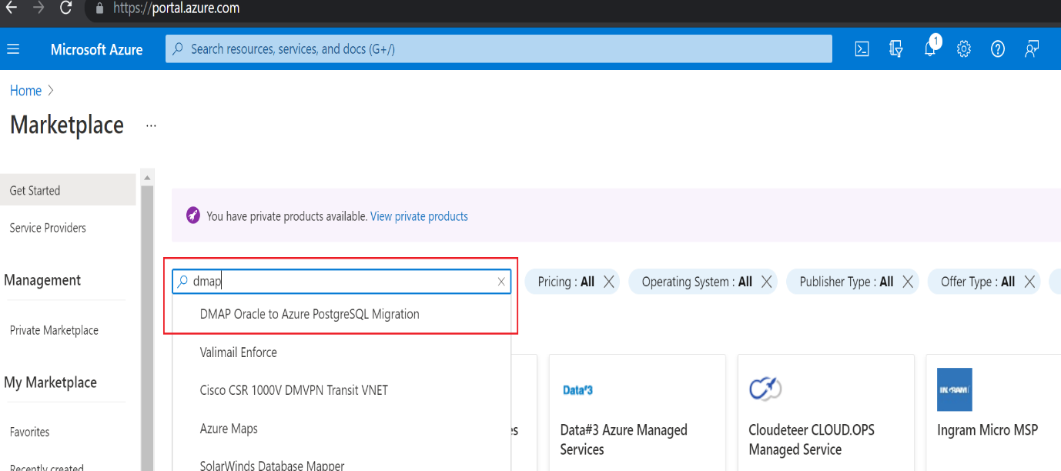

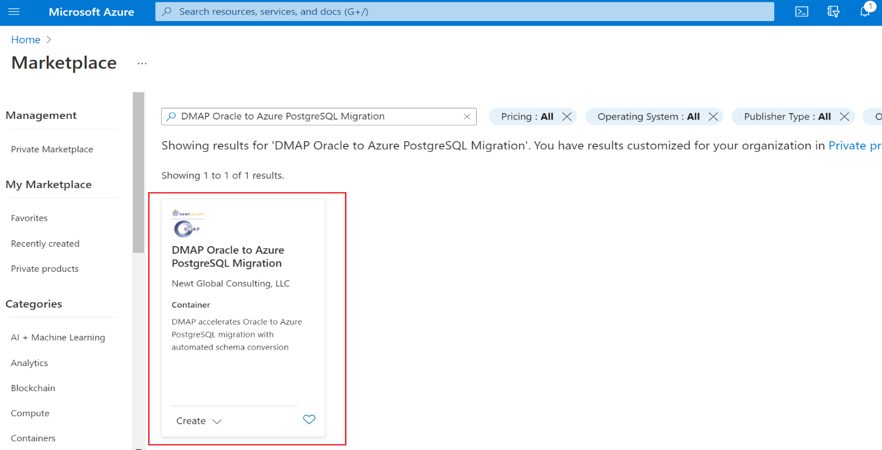

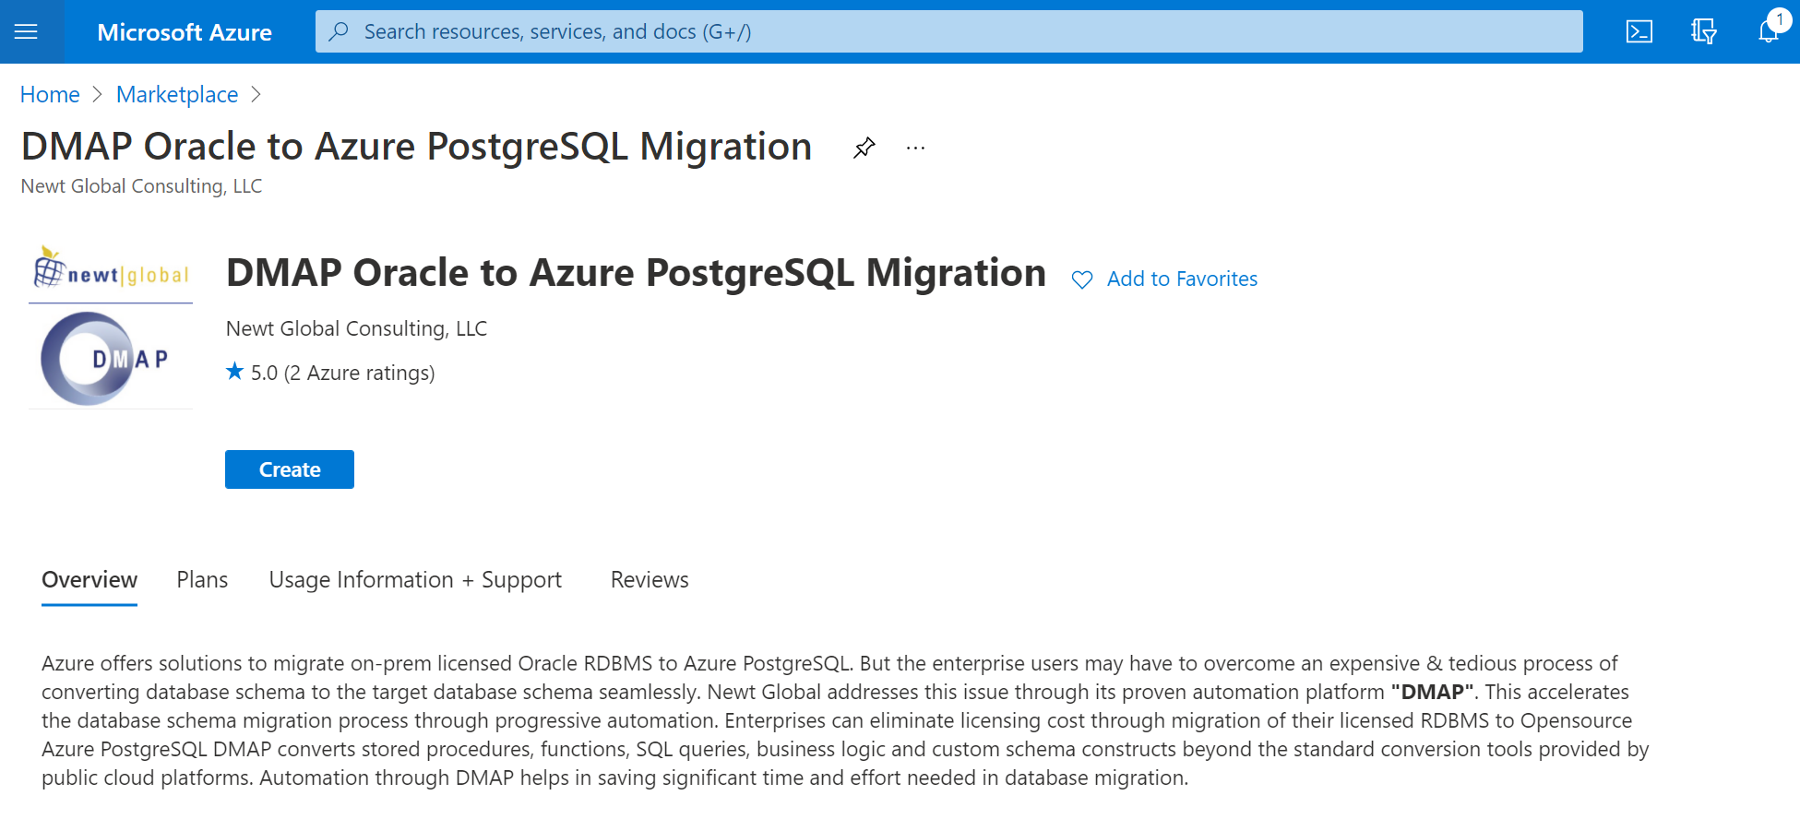
Click on “Create” button, that will take you to “Subscribe” page. Enter all required details on “Subscribe” page and click on “Subscribe” button to create a new or update an existing Azure Container Registry with the DMAP image.

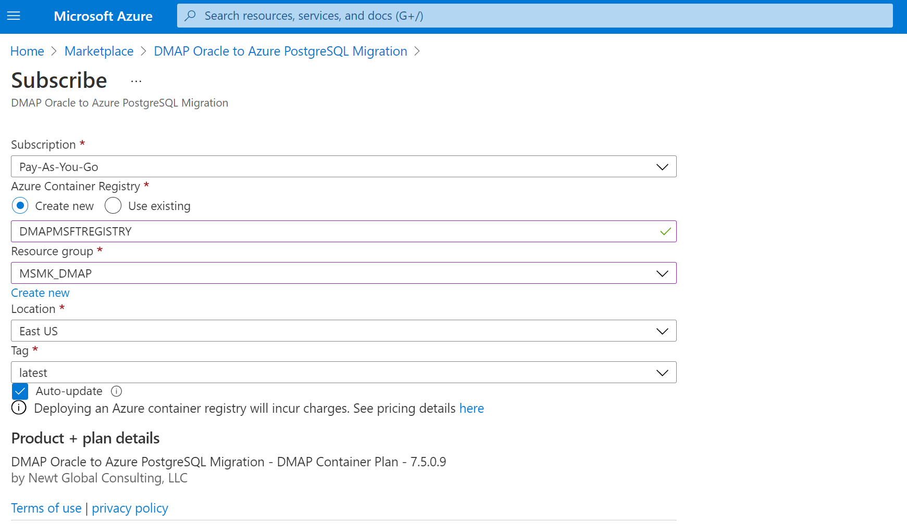

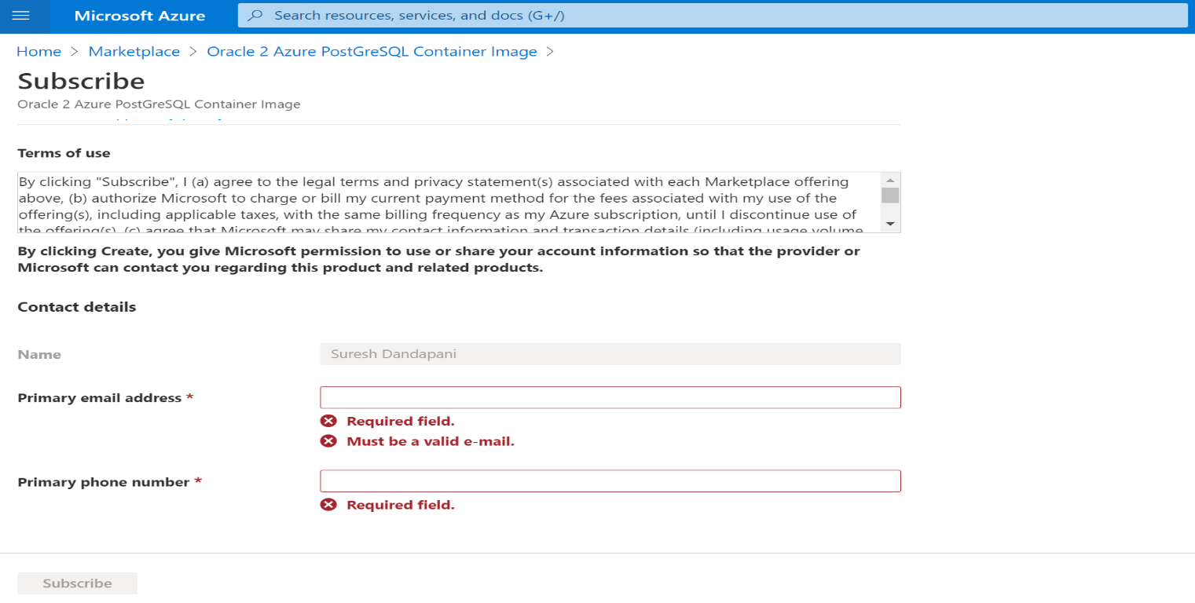
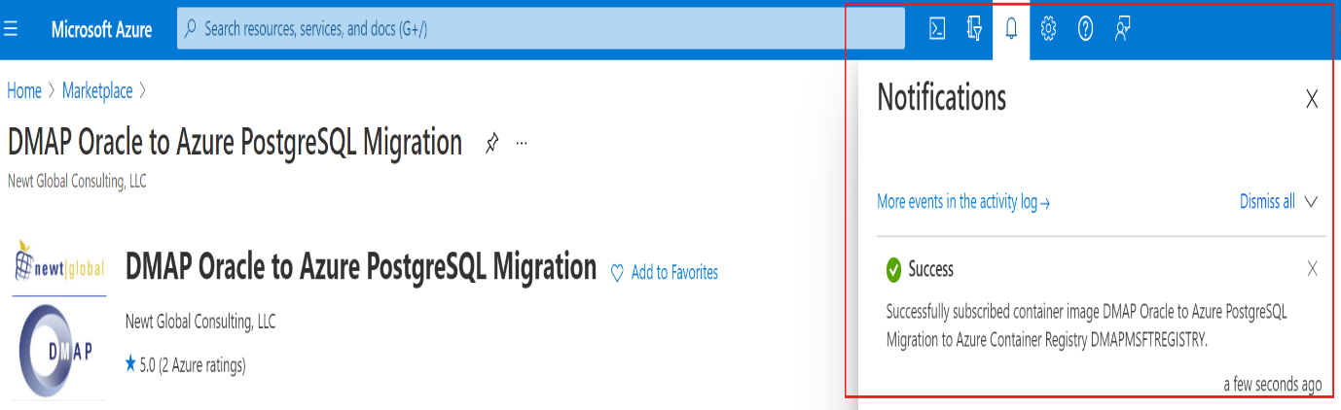

Note: Above images depicts sample inputs for reference.
Next, go to “Container registries” services to verify that the container registry has been created.
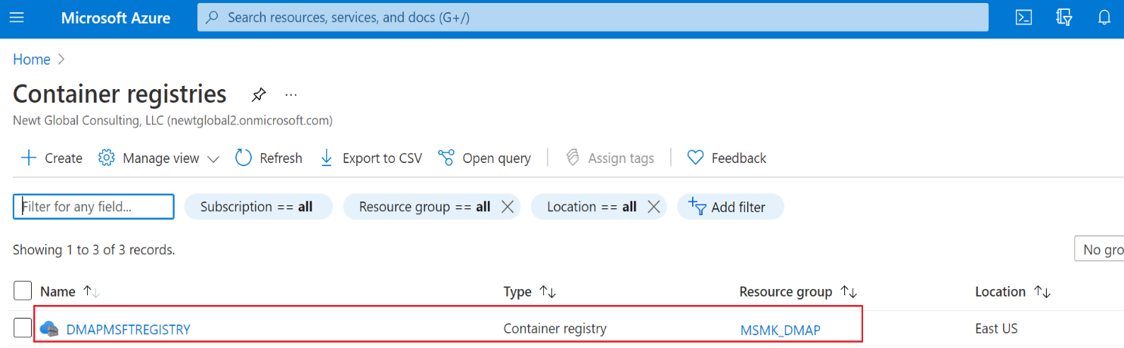

Select the registry and verify that Repository contains the DMAP image.
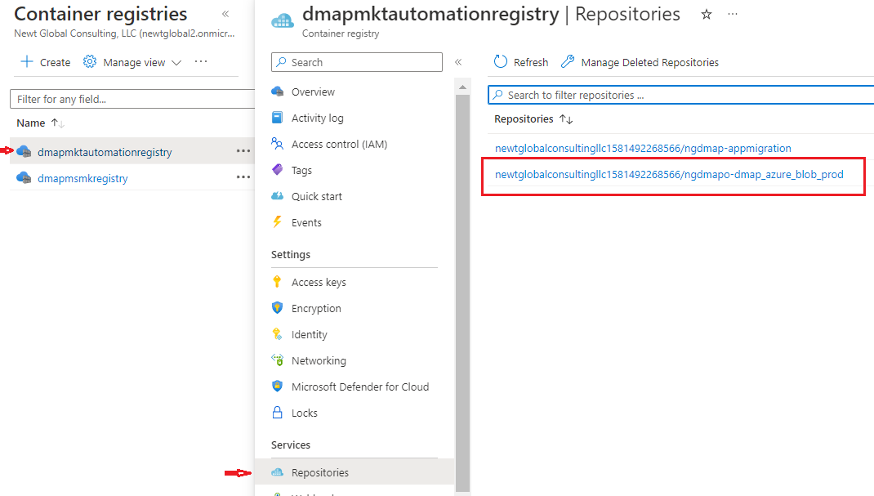
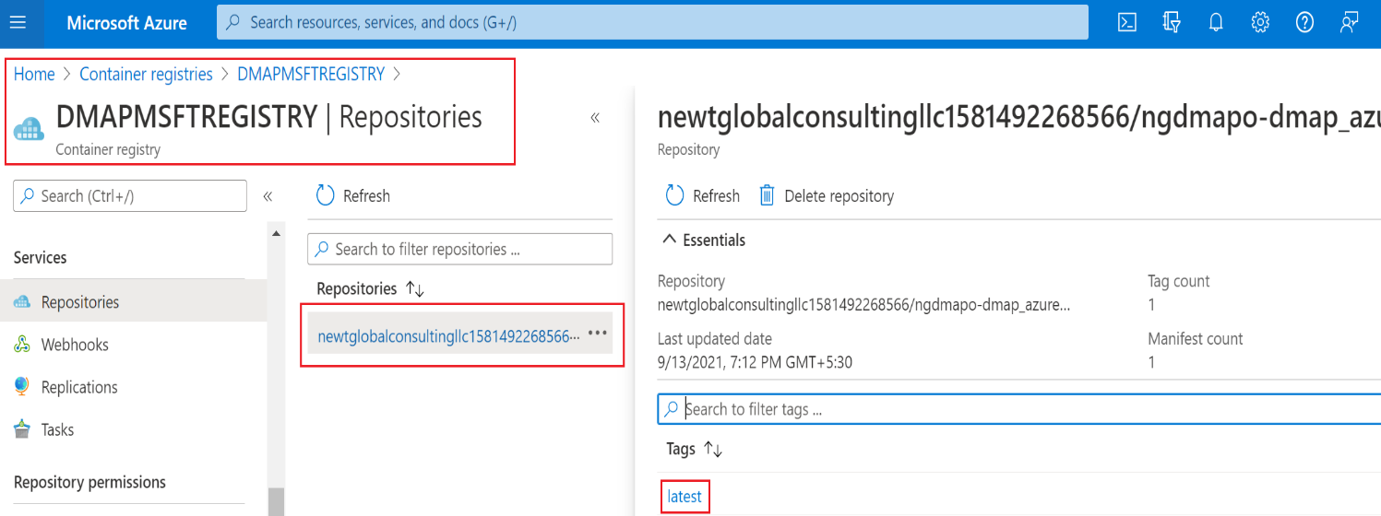
Note: Above images depicts sample registry, repositories and docker image with latest tag. “Admin” access should be enabled for the created registry. To enable admin access, go to registry and enable “Admin” as shown below.
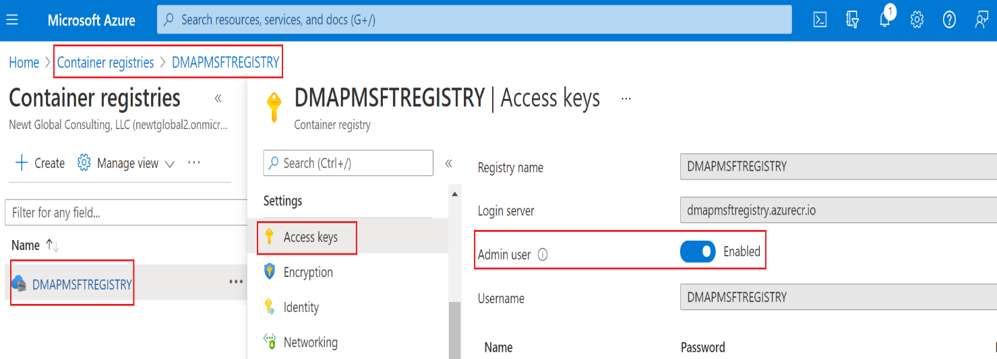

Create ACR for Application Migration
Create an Azure Container Registry to store the DMAP App Migration image from Azure Marketplace which will be used to install DMAP App Migration in the VM. To create Azure Container Registry for DMAP App Migration, Login to Azure portal and go to Azure Marketplace. Search for “DMAP App Container Offer in Azure” as shown below.

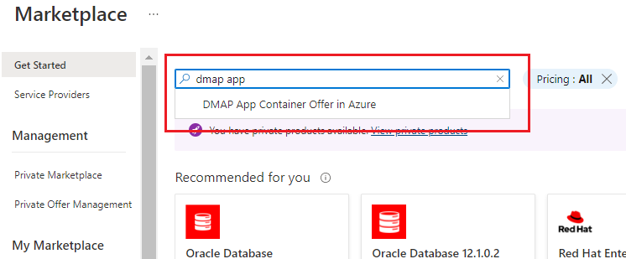

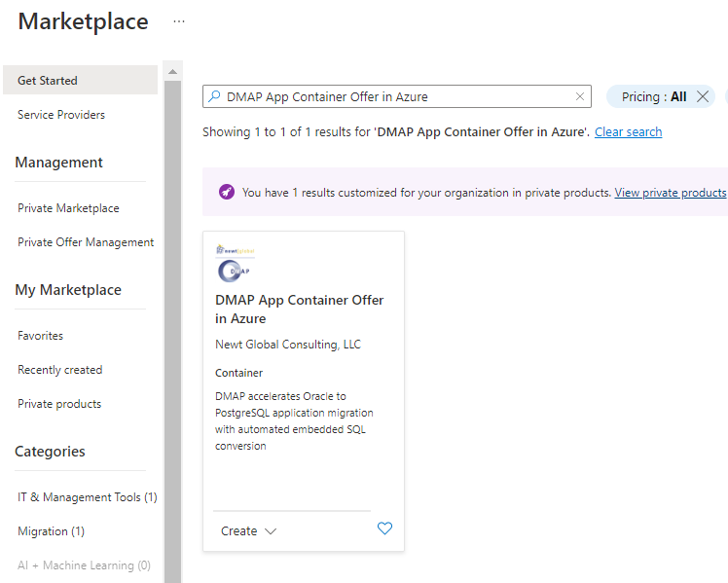

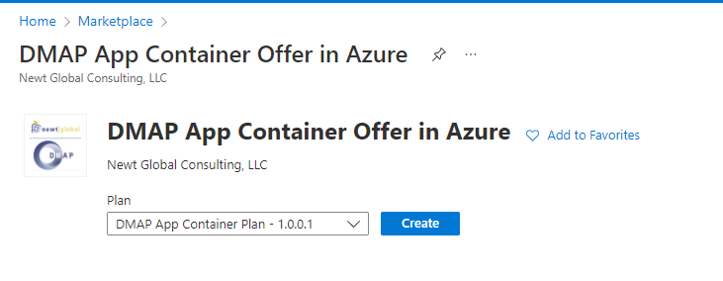
Click on “Create” button, that will take you to “Subscribe” page. Enter all required details on “Subscribe” page and click on “Subscribe” button to create a new or update an existing Azure Container Registry with the DMAP image.

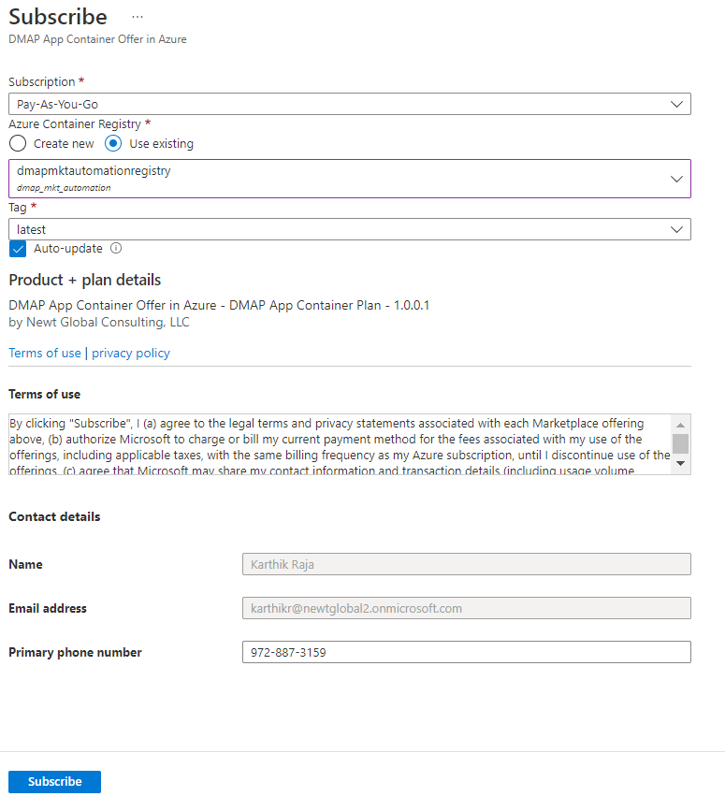

Note: Above images depicts sample inputs for reference.
Next, go to “Container registries” services to verify that the container registry has been created.

Select the registry and verify that Repository contains the DMAP image.
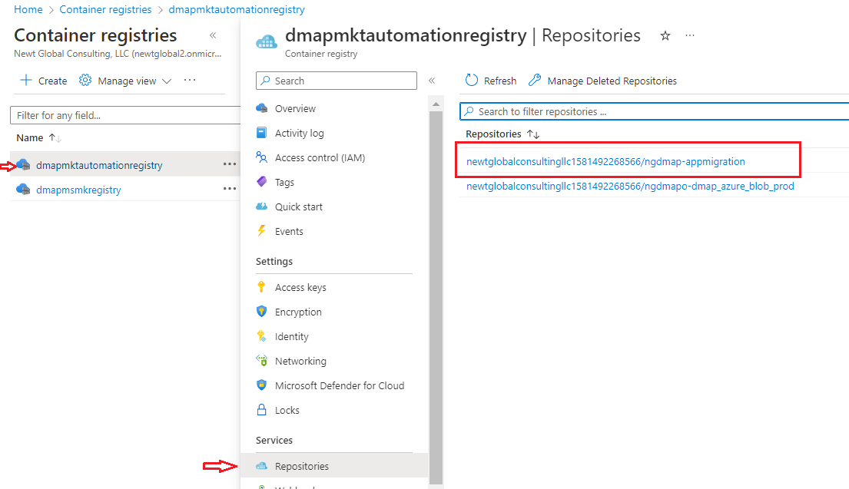
Note: Above images depicts sample registry, repositories and docker image with latest tag. “Admin” access should be enabled for the created registry. To enable admin access, go to registry and enable “Admin” as shown below.

Installation Procedure
If you wish to run DMAP for performing assessment and conversion of few schemas only, then you shall setup only DB Master Node container.
Optionally, to perform assessment at scale, multiple DB Worker Node containers can be setup each running a separate instance of DMAP to run assessments of multiple databases in parallel in a short time. Both Master and worker node containers can be setup on same or different VMs. Since DMAP uses docker based containers, Docker must be installed on each VM.
Follow below installation procedure to complete installation of DMAP.

5.1 Install Docker
- Download docker software from docker official website (based on your operating system) mentioned below and install it, if not installed already.
https://docs.docker.com/engine/install/
- For RHEL and CentOS, follow installation steps given in page https://docs.docker.com/engine/install/centos/
- For Ubuntu OS, follow installation steps given in page https://docs.docker.com/engine/install/ubuntu/
- For Windows OS, follow the installation steps given in page https://docs.docker.com/desktop/install/windows-install/

5.2 Pull DMAP Image from ACR
- Install Azure CLI utility from https://docs.microsoft.com/en-us/cli/azure/install-azure-cli , if not installed already.
- Make sure you have access to Azure Container Registry (ACR) with permission to PULL images with roles that are assigned any one of the following:
Owner, Contributor, Reader, AcrPush, AcrPull or custom role.
- Open terminal or command prompt and run below command.
az login
It will open the web browser and prompt you to enter your Azure account login credentials. Once successfully logged in, command prompt will show success message.
- Next, run below command to log into ACR in which DMAP DB Migration Container and DMAP App Migration Container images were downloaded in Section 4, Create Azure Container Registry (ACR) and Download DMAP Images. If you downloaded both DMAP images in different ACRs, then execute command to log into each ACR to download the respective image.
az acr login –n <<??azure_container_registry_name??>>
This will verify your ACR access. Once successfully logged in, command prompt will show “Login Succeeded” message.
<<??azure_container_registry_name??>> is name of the azure container registry in which DMAP docker image has been pulled into from Marketplace. This was setup while creating “Azure Container Registry” in section 4. For reference, see below image.

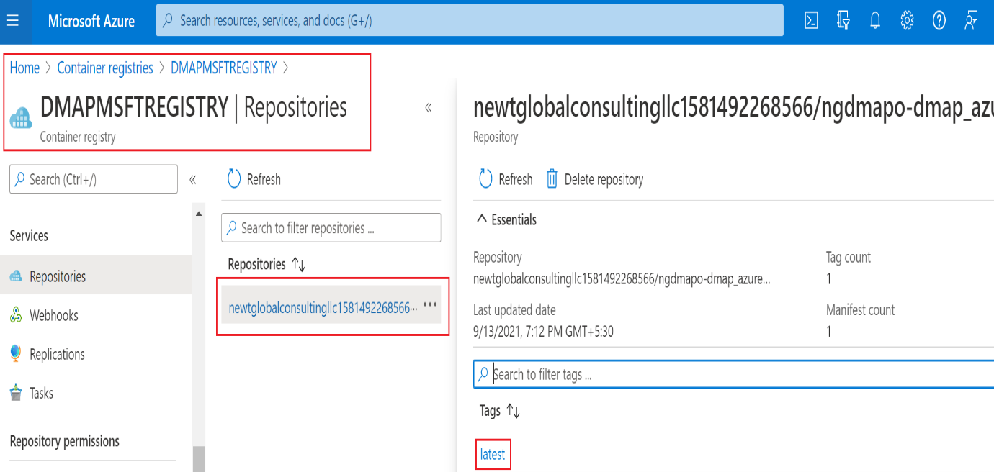

- After successfully logging into ACR, run the below to pull the DMAP docker image (DB Migration or App Migration Container Image).
docker pull <<??image_name??>>:<<??tag??>>
  - <<??image_name??>> - name of the docker image
  - <<??tag??>> - tag name
Above values can be referenced from the azure portal. Or simply click on the copy icon to copy the pull command and execute it on your terminal or command prompt.
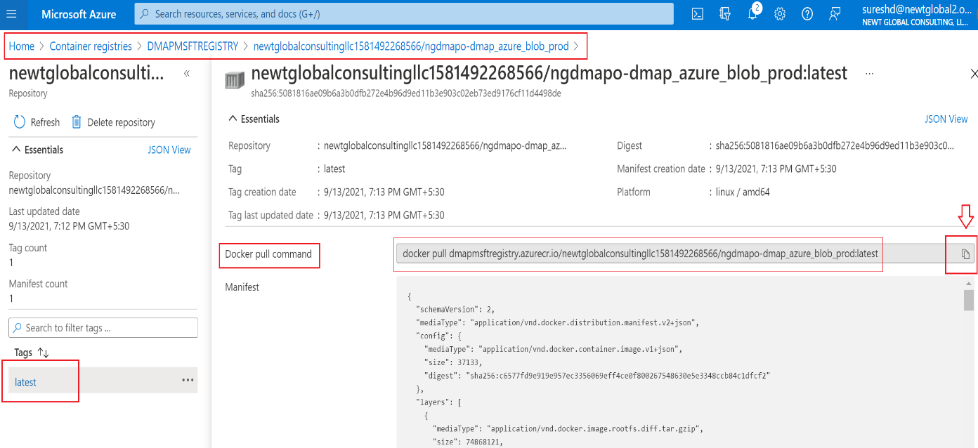
- To check the image is pulled from docker registry, run the below command to view the list of all the downloaded images.
docker images

5.3 Setting up DB Master & Worker Node Containers

5.3.1 DB Master Node Container Setup
- To create the master container from DMAP image for the first time, use the below command.
docker run -d -it -p {DB_PORT}:5432 -p {UI_PORT}:8080 -p {PYTHON_SERVICE_PORT}:5002 -e UI_PORT={UI_PORT} -e SERVICE_PORT={PYTHON_SERVICE_PORT} -e DB_PORT={DB_PORT} --name=dmap_db_master <<??downloaded_docker_image_name??>>:<<??tag??>>
Where:
<<??downloaded_docker_image_name??>> is name of the DMAP DB Migration docker image downloaded from ACR
<<??tag??>> is tag of the ACR image
- To create the master container, following sample command can be used:
docker run -d -it -p 5432:5432 -p 9090:8080 -p 5002:5002 -e UI_PORT=9090 -e SERVICE_PORT=5002 -e DB_PORT=5432 --name=dmap_db_master <<??downloaded_docker_image_name??>>:<<??tag??>>
- Please make sure:
  - UI_PORT, PYTHON_SERVICE_PORT, and DB_PORT can be any port. Make sure PORT highlighted in same colour have same port number.
  - Port numbers are available and not used by any other process or DMAP container running in the VM in which DMAP is installed.
- To start the DMAP Master and Worker Node containers if not running already, execute following command:
  - docker start [Master or Worker Node container instance name]
- To stop the DMAP Master or Worker Node containers execute following command:
  - docker stop [Master or Worker Node container instance name]

5.3.2 DB Worker Node Container Setup
- Follow same steps as mentioned in “DB Master Node Container Setup” but make sure for each container UI_PORT, PYTHON_SERVICE_PORT, and DB_PORT is unique if they are setup in the same VM.
- Worker containers can be created in same or different VMs. If they are created in different VMs, they can use same port numbers otherwise port numbers have to be unique on each machine.
- To create each DB worker container in a separate VM, following sample commands can be used. Here, we are setting up two worker containers as an example.
docker run -d -it -p 5433:5432 -p 9093:8080 -p 5003:5002 -e UI_PORT=9093 -e SERVICE_PORT=5003 -e DB_PORT=5433 --name=dmap_db_worker1 <<??downloaded_docker_image_name??>>:<<??tag??>>

docker run -d -it -p 5433:5432 -p 9093:8080 -p 5003:5002 -e UI_PORT=9093 -e SERVICE_PORT=5003 -e DB_PORT=5433 --name=dmap_db_worker2 <<??downloaded_docker_image_name??>>:<<??tag??>>
- To create DB worker containers in same VM, following sample commands can be used. Here, we are setting up two worker containers as an example.
docker run -d -it -p 5433:5432 -p 9093:8080 -p 5003:5002 -e UI_PORT=9093 -e SERVICE_PORT=5003 -e DB_PORT=5433 --name=dmap_db_worker1 <<??downloaded_docker_image_name??>>:<<??tag??>>

docker run -d -it -p 5434:5432 -p 9094:8080 -p 5004:5002 -e UI_PORT=9094 -e SERVICE_PORT=5004 -e DB_PORT=5434 --name=dmap_db_worker2 <<??downloaded_docker_image_name??>>:<<??tag??>>

Setting up App Master & Worker Node Containers
- Similar to DB Master and Worker Node containers setup explained above, to run application assessment and conversion using DMAP, App Master and Worker Node containers can be setup.
- To create a container using DMAP App Migration image for the first time, run the below command.
  - docker run -d -it -p {JAVA_SERVICE_PORT}:8080 -p {APP_PORT}:5000 --name=dmap_app <<??downloaded_docker_image_name??>>:<<??tag??>>
Where:
<<??downloaded_docker_image_name??>> is name of the DMAP App Migration docker image downloaded from ACR
<<??tag??>> is tag of the ACR image
  - To create container, following sample command can be used:
docker run -d -it -p 8090:8080 -p 5020:5000 --name=dmap_app <<??downloaded_docker_image_name??>>:<<??tag??>>
  - Note:
    - JAVA_SERVICE_PORT and APP_PORT can be any port.
    - Make sure port numbers used are available and not used by any other process or DMAP container in the VM.
    - Container name i.e. dmap_app in above example shall be replaced with actual master or worker container name
- To start the DMAP App container if it is not already running, execute following command:
  - docker start [Master or Worker Node container instance name]
- To stop the DMAP App container, execute following command:
  - docker stop [Master or Worker Node container instance name]

6. Activating DMAP License

6.1 Registering DB Master Node Container
When DMAP container is started, it will download fresh binary files for GUI and backend services updates for the first time. In subsequent runs, it checks if a newer version is available and downloads it from Azure BLOB storage. So, depending upon speed of your internet, please wait for 5 – 15 minutes for DMAP to download these files and then proceed to next step to open the login page. While binaries are downloading, login page will not be accessible.
Make sure below ports are open for access in the VM in which DMAP DB / App containers are installed:
- UI_PORT for DB Container
- PYTHON_SERVICE PORT for DB Container
- APP_PORT for App Container

Note: UI of DMAP is accessed through the URL of DB Master Node container only. However, we need to register the DMAP license once for each DMAP DB Worker Node container by accessing its UI.
Once Master and Worker Node containers setup is complete. Follow below steps to access DMAP.

6.1.1 Login
Open Google Chrome web browser in DMAP VM or in a different machine. DB Master Node container hosting DMAP should be accessible from the VM/Machine. Next, enter below URL in web browser to access DMAP using UI Port of DB Master Node container.
http://{DB_Master_Node_VM_IP}:{UI_PORT}/DMAP
DB_Master_Node_VM_IP is IP address of VM hosting DB Master Node container.
UI_PORT is UI Port setup for DB Master Node container.

If DMAP DB Master container is running on IP 192.168.12.10 at port 9090 then URL will be
http://192.168.12.10:9090/DMAP

Note: DMAP in URL shall be typed in upper case.
Enter username and password to login. If you do not have username and password setup yet, then follow next step to create user account.
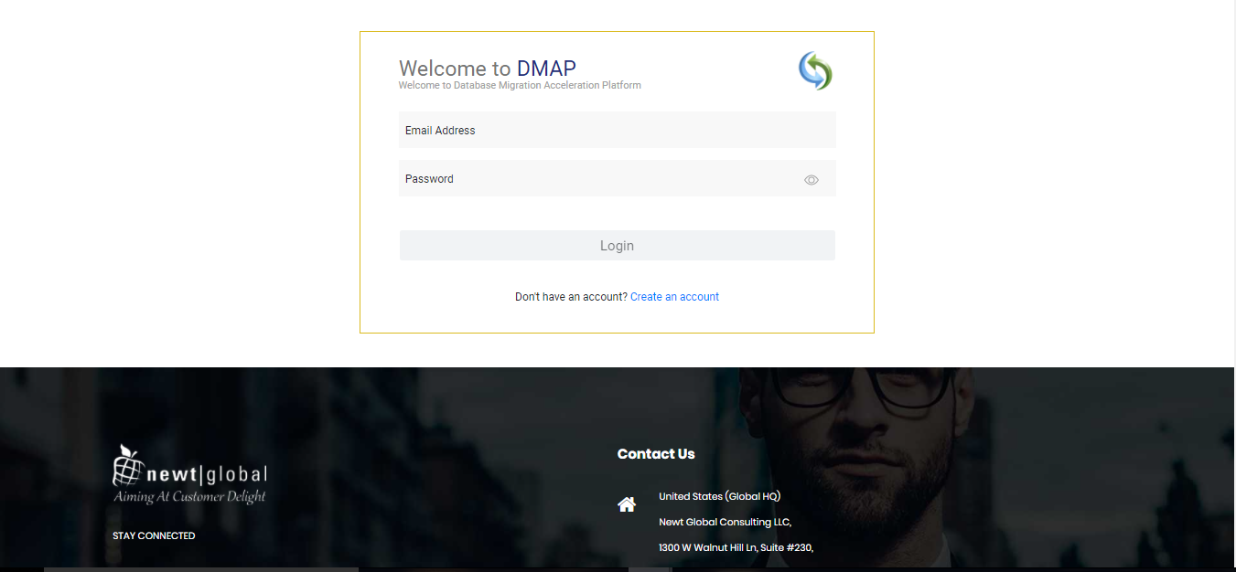

6.1.2 Create Account
First time user is required to create a new account by clicking “Create an account” link on the Login page. Only one user account is allowed per DMAP Master Node container. For additional users (if license permits), please install and setup a separate instance of DMAP Master and Worker Node conatiners.
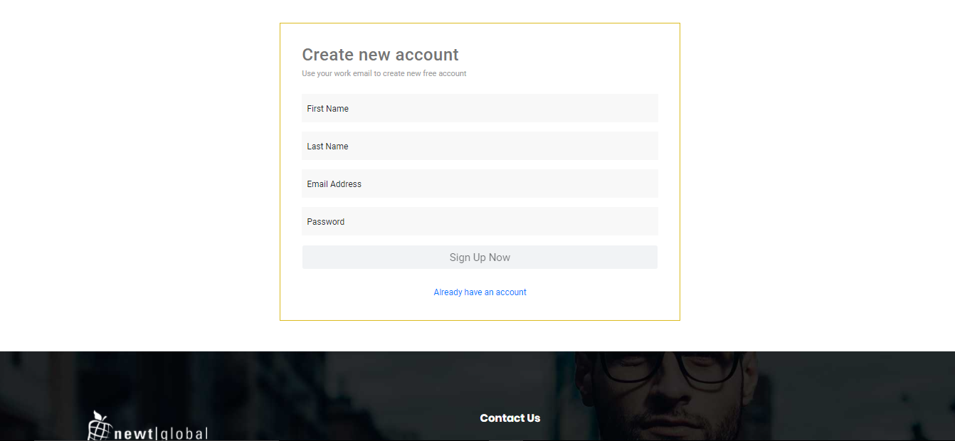

After signing up, enter the email id in the “Email Address” and password in the “Password” text box of login page. Ensure that email id is entered in a valid email format and click on “Login” button.
After successful login, user will be directing to buy license page. To buy a license or renew the license, you must contact DMAP sales team. DMAP sales team details will be shown on the license activation page. Or alternatively you can enter the license key of Trial license of DMAP if you have one.

6.1.3 Activate License
To activate DMAP license, enter License key and accept the License Agreement.
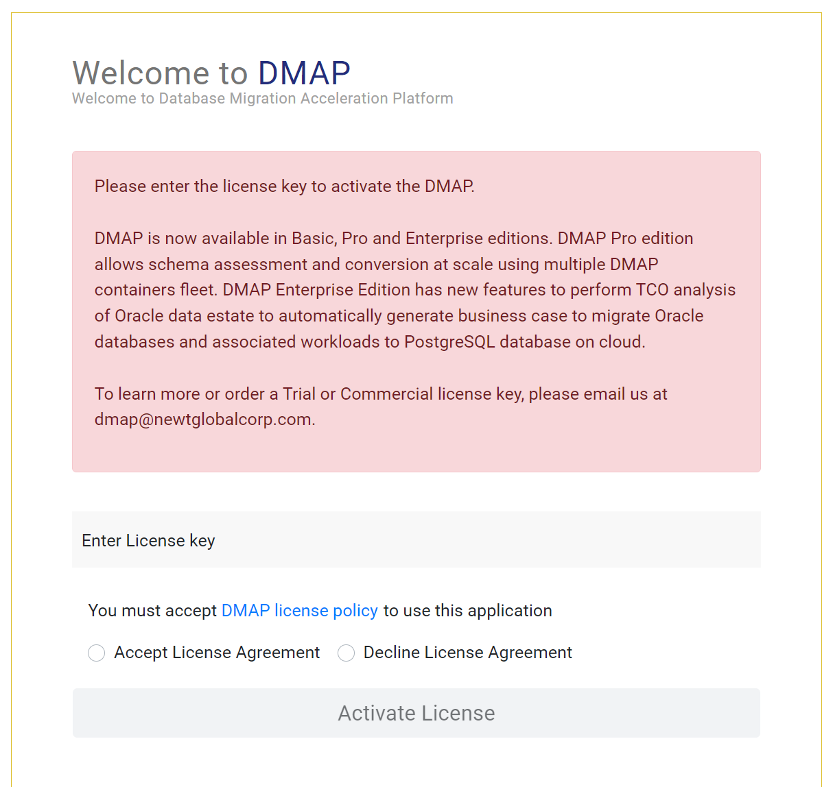

Note: Trial or Commercial license will be shared and explained separately by sales team. You can reach out to Sales team through email (dmap@newtglobalcorp.com) or by visiting our website (https://newtglobal.com/platform-enquiry) to submit DMAP enquiry with your request.
Next, click on Activate License button which will direct you to Get Started with Migration Page. To use DMAP, please refer to the User Guide provided to you.

6.1.4 Configure DB Master Node Container
After DMAP license is activated successfully, user will see “DMAP Node Type Selection” screen. Select “Master” to setup DMAP DB Master Node container.
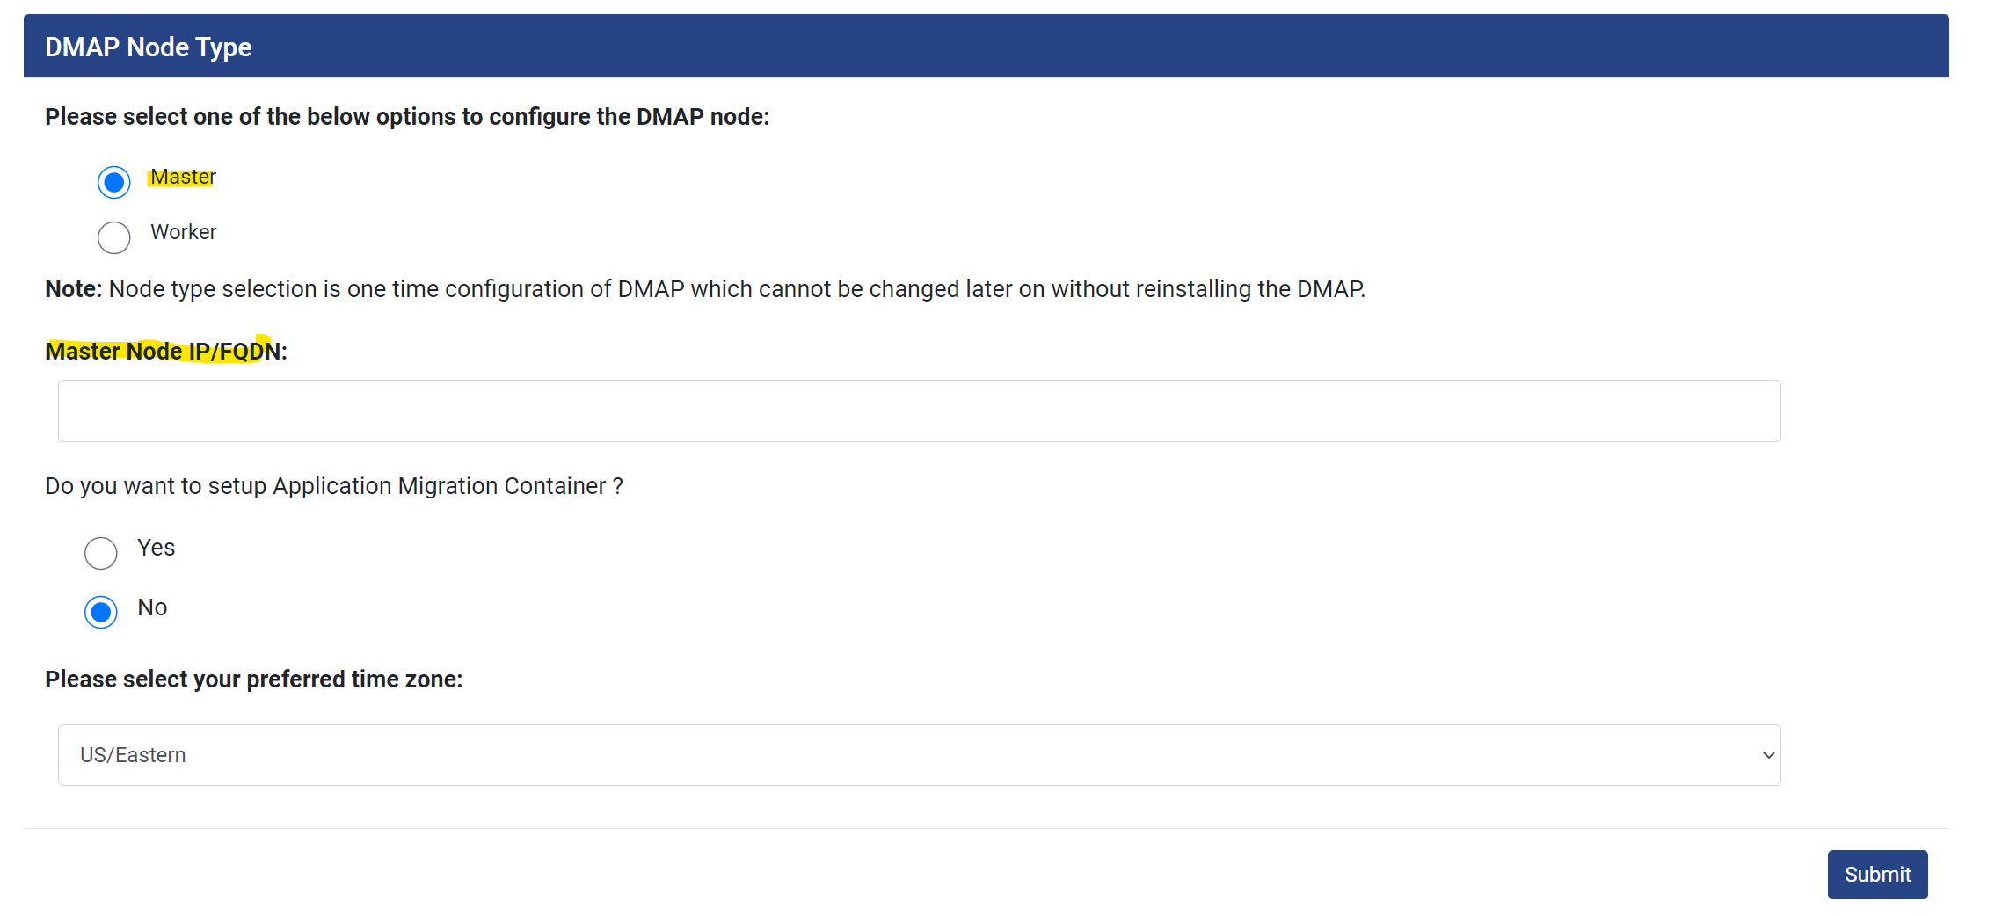
Note: Based on license type settings screen will differ.
- For “DMAP Basic” license, only time zone selection will be required. All reports and screens will display date in the selected time zone.
- For “DMAP Pro” and “DMAP Enterprise” license:
  - Select the DMAP DB Node container being activated as “Master” or “Worker”. Multiple worker nodes can be setup if you wish to perform data centre assessment of schemas at scale. In this mode, DB Master Node container distributes schemas to be accessed across multiple DB Worker Node containers. Only one container will be configured as Master which collects assessment results from individual worker node containers and displays assessment summary in DB Master Node container. Master node container can also function as worker node container and can also run schema assessments and conversions.
  - To perform assessment at scale, configure one DMAP DB Node container as “Master” and remaining as “Worker”. If you wish to run DMAP for performing assessment and conversion of few schemas only, then select “Master” node option.
  - if you select node type as “Master” node, then enter master node VM IP address in “Master Node IP/ FQDN” text field.
  - Finally, select the preferred time zone for displaying time in reports and screens.

6.2 Registering DB Worker Node Containers
To register and activate license for each DB Worker Node container, follow same steps as described in “Registering DB Master Node Container” section with below considerations:
- Use below link to access the login page for Worker Node container.
http://{DB_Worker_Node_VM_IP}:{UI_PORT}/DMAP
- Create user account and activate the DMAP using your license key. In “DMAP Node Type Selection” screen shown below, select “Worker” node option.
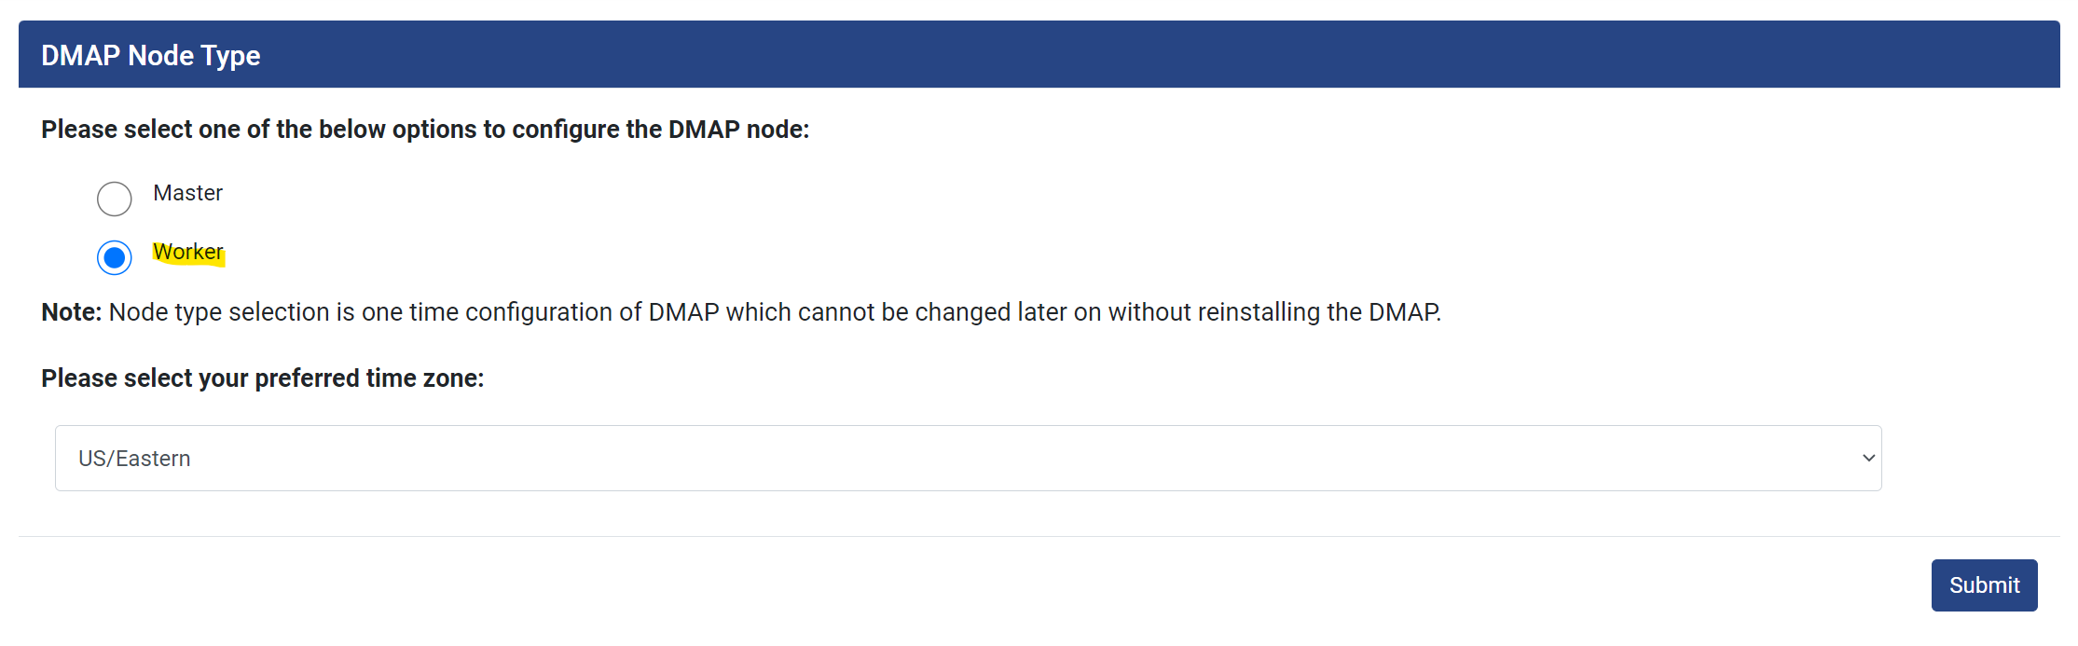
- Once license has been activated, there is no need to access DMAP Worker Node container UI because we use DMAP DB Master Node container UI to assess schemas.

7. Worker Node Setup
In “Worker Node Setup” tab, you can configure DB Worker node containers.
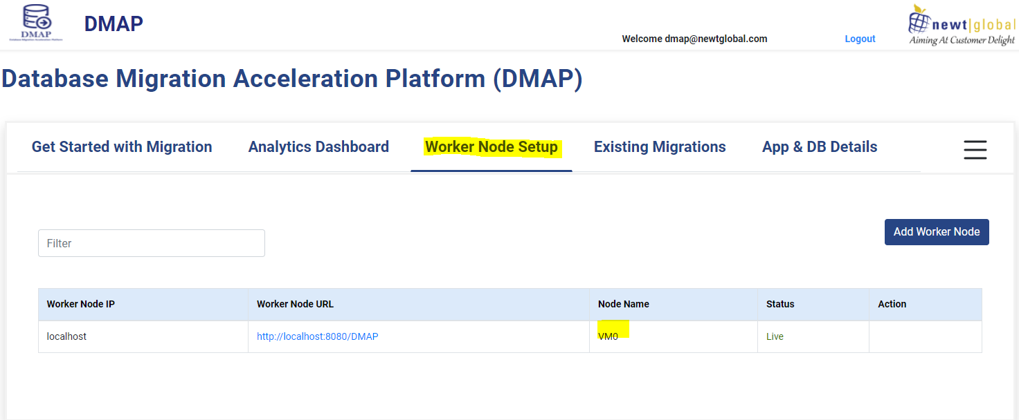
Note: DB Master Node container will also work as worker node and will be displayed with Node Name as “VM0”. Master node will have only option to “Resync”.
Click on “Add Worker Node” to add worker node. Fill all the required fields. Click on “Test Connection” to verify if you can connect to the worker node.
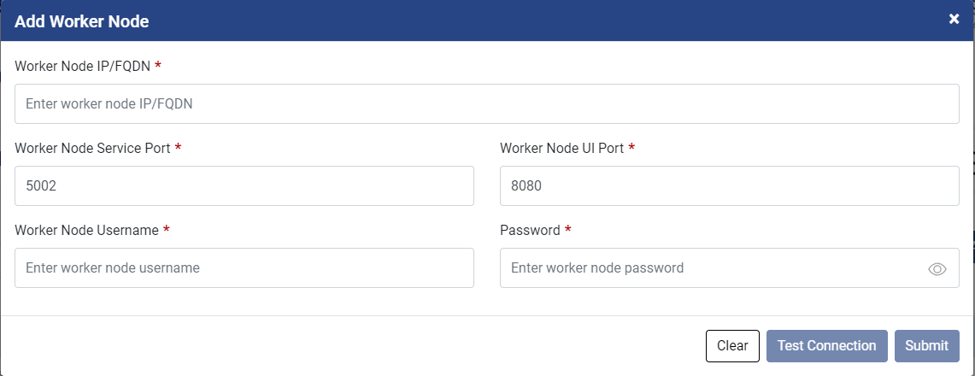
Click on “Submit” to configure a worker node. On clicking on submit button, you will get confirmation dialogue box as shown below.
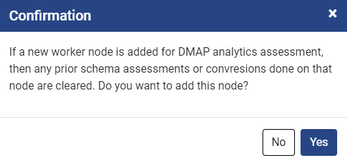
Note: If a new worker node is added for DMAP analytics assessment, then any prior schema assessments or conversions done on that node are cleared.
Worker Node Configuration Details
Field Name | Type | Values to be Entered | Mandatory
Worker Node IP/FQDN | Text Box | Host address (either IP address or the host URL or hostname) of worker node | Yes
Worker Node Service Port | Text Box | Worker node service port number (e.g, 5200) | Yes
Worker Node UI Port | Text Box | Worker node UI port number (e.g, 8080) | Yes
Worker Node Username | Text Box | Worker node DMAP username | Yes
Password | Text Box | Worker node DMAP password | Yes

7.1 Worker Node Options
You can perform below highlighted operations on inactive worker node.
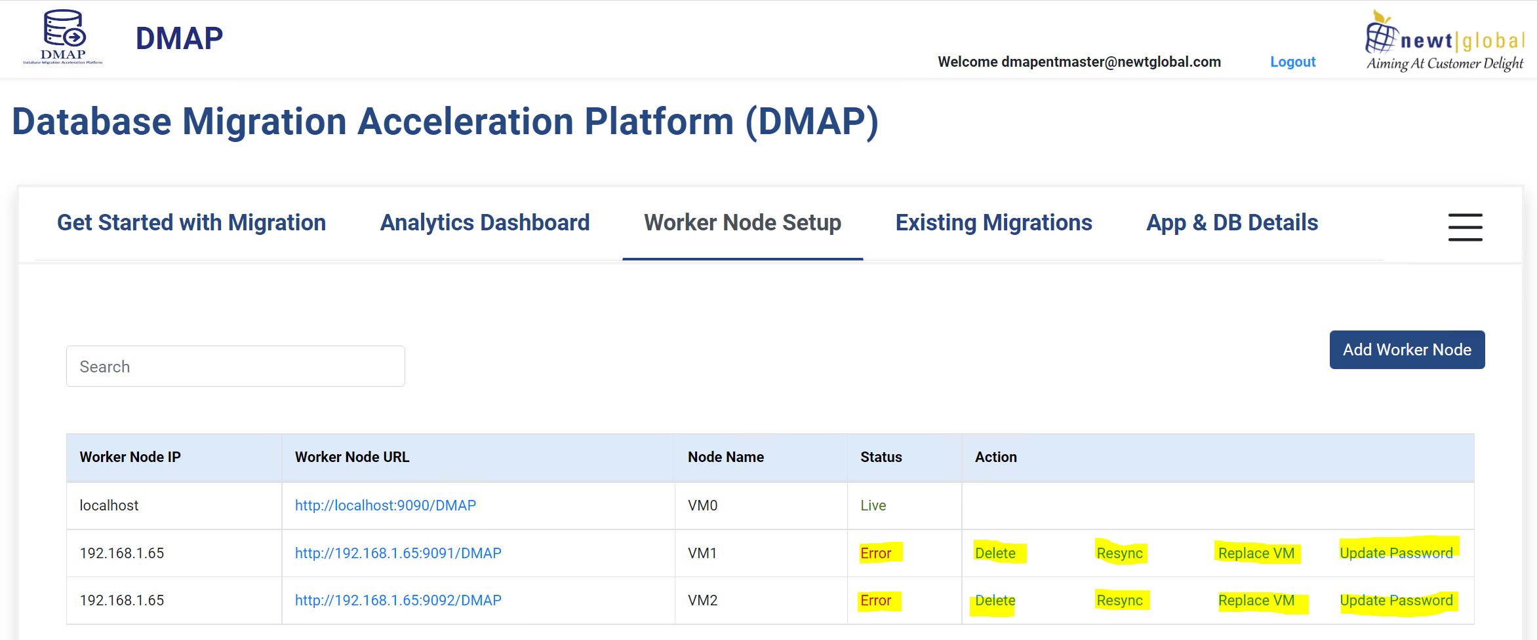
Delete Worker Node
You can delete worker node on clicking “Delete”. Deleting a worker node will remove all database assessments performed on the node which cannot be recovered later.

7.2 Resync Worker Node
If worker node container is not reachable from master node, then status will show as “Error”. Once the worker node container connectivity issue has been resolved, you can click on “Resync” to verify that DMAP can connect to the worker node. If connection is successful, then status would change to “Live”.

Replace VM
You can replace inactive worker node with a new active worker node. Clicking on “Replace VM”, you will get a popup screen to configure new worker node details just like add worker node.
This action will restore most recent worker node backup (which is automatically taken by DMAP Master node periodically) which will be replaced in the new worker node.
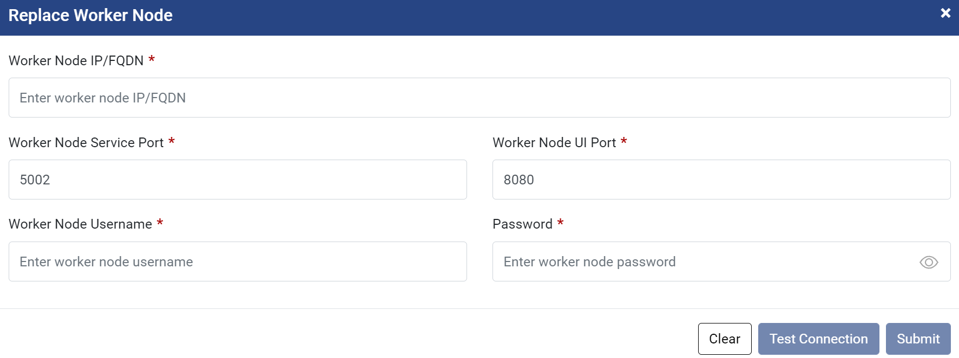

7.4 Update Password
If worker node DMAP password was changed, you can update password on selecting “Update Password” as shown in screenshot.
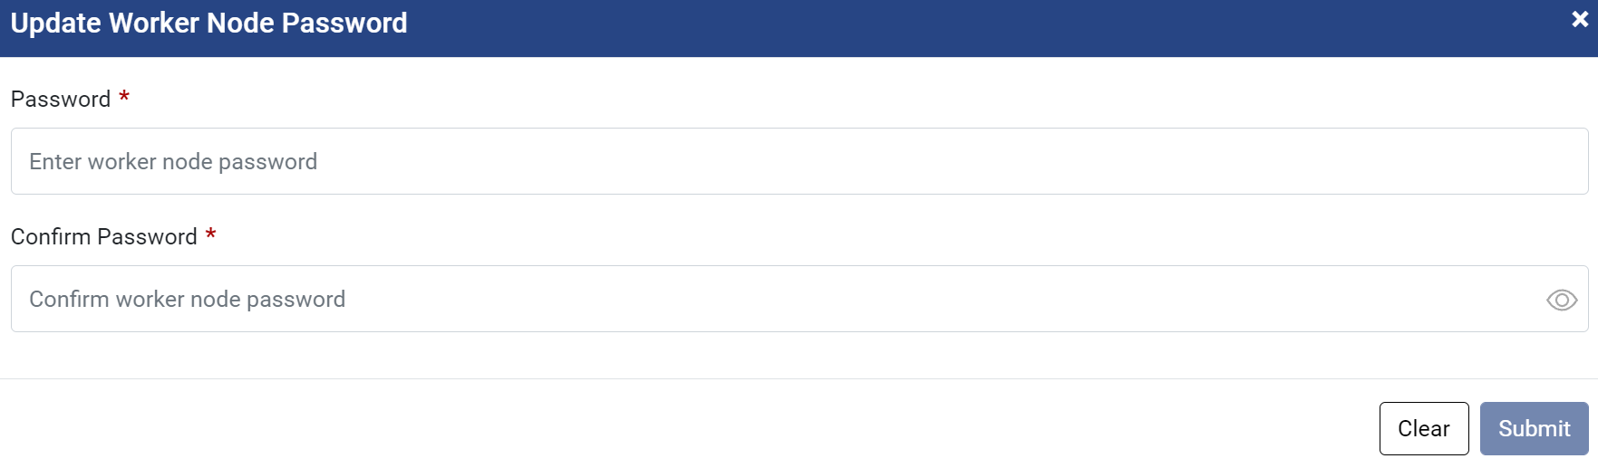

8. Troubleshooting
Below are some tips that may help the user to troubleshoot and resolve common errors.
If the user faces any issues in configuring DMAP, please contact Newt DMAP Support Group dmap_support@newtglobalcorp.com

8.1 Unable to Log In to DMAP
- Verify that log in request from workstation used to access DMAP web app can reach the Virtual Machine and correctly show its IP address in request header.
- On Login Page, “Login” button is disabled if email address is not entered in a valid email format. So, make sure email address is valid and then click on Login button.
- Login inside container and check following required services are running properly.
  - Postgres DB
  - GUI (Tomcat)
  - Backend (Service)
- To check running services list in docker container
  - Launch container shell either using docker command “docker exec -it --user=root <<your_container_name>> bash” in terminal or using Docker Desktop (Windows only) dashboard.
  - Inside the shell, execute command “ps -aux” as mentioned below.
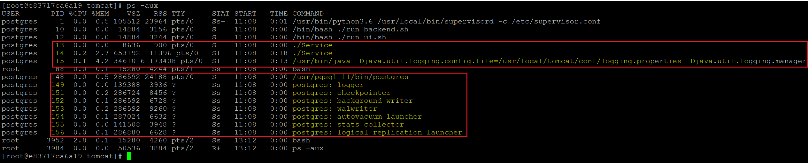
  - “./Service” – confirms DMAP backend service is started and listening to client request.
  - “/usr/bin/java -Djava.util.logging.config.file=/usr/local/tomcat/conf/logging.properties -Djava.util.logging.manager” – confirms DMAP GUI service is started and running for user to access DMAP UI from the chrome browser.
  - “/usr/pgsql-11/bin/postgres” and related services as highlighted in the image confirms that PostgreSQL has started and running.
- If any of the above required services are not running, try restarting the container once. If issue still persists, follow below steps:
  - To start Postgres service, execute “pg_ctl stop” command followed by run “pg_ctl start” command. If service is still not started, get Process ID by running command “pg_ctl status” and then using the returned PID, kill the process using command “kill -9 <<PID>>”
  - To start GUI service, execute “catalina.sh run” command.
  - To start Backend services, change directory to “cd /usr/local/tomcat/Service” and followed by run “./Service”.

8.2 DMAP Login Page is Not Displayed
- If you are accessing the Master DB Node container UI from a browser running in a different VM, then make sure that UI and Service ports for DMAP are open for access.
- Make sure DMAP is typed in upper case in the URL below:
http://{DB_Master_Node_VM_IP}:{UI_PORT}/DMAP
- Whenever DMAP container is started (including first time), it checks if a new update is available and downloads it from Azure BLOB. This may take 5 – 15 minutes depending on speed of your internet. Please wait for DMAP to download the update and access login page after some time.

9. Support
For immediate assistance, please contact us on dmap_support@newtglobalcorp.com and one of our technical team members will work with you to resolve your issue.

