DMAP AWS Installation Manual

Version 7.5
Date: November 08, 2021

Newt Global Consulting
1300 W Walnut Hill Ln | Suite # 230 | Irving TX 75038
Phone: +1 972 887 3159 | Fax: +1 214 260 6051
Contents
1. Introduction 3
2. Overview of DMAP 3
3. Prerequisites 4
3.1 System Requirements 4
3.2 Prerequisites 4
4. Download DMAP Docker image from AWS Marketplace 5
5. Create Repository in Elastic Container Registry (ECR) 11
6. Upload downloaded DMAP docker image into ECR 13
7. DMAP Container Creation 16
7.1 Creating container in Elastic Container Service (ECS) 16
7.2 Creating Container in User’s Workstation 33
8. Support 37
9. Appendix 37
9.1 Create Account 37
9.2 Activate License 38
9.3 AWS Configure 39

Introduction
This document explains how user can setup DMAP docker image available in Aws Marketplace in Elastic Container Registry (ECR) and create a container from it in Elastic Container Services (ECS) or in user’s workstation to run DMAP.

Overview of DMAP
DMAP will help to accelerate the database schema conversion process from Oracle to PostgreSQL through progressive automation of stored procedures, functions, SQL queries, business logic and custom schema constructs beyond the standard conversion tools provided by public cloud platforms.
Below is the Deployment Architecture of DMAP.
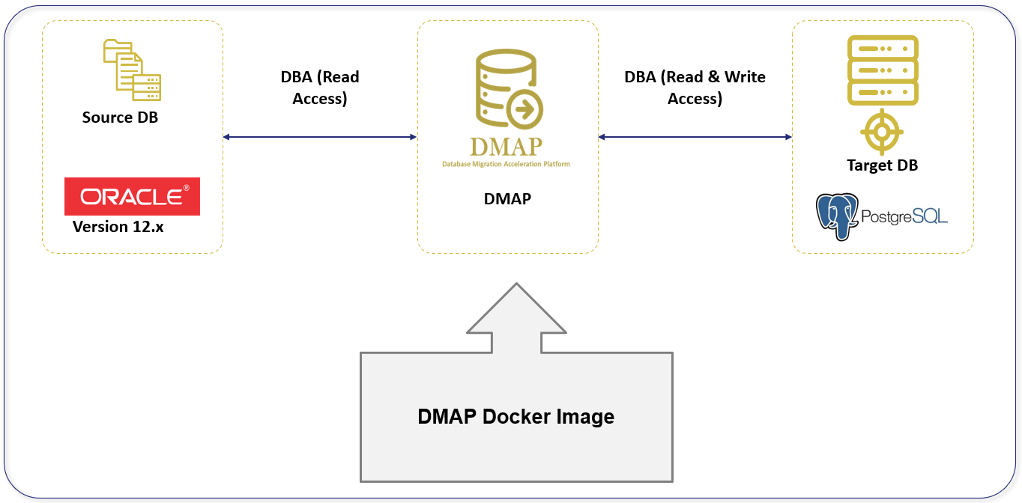
Source Oracle DB and target PostgreSQL DB should both exist, and they are configured in DMAP application to run the automated conversion.

Prerequisites
Please make sure below pre-requisites are fulfilled to install DMAP and use it.

System Requirements
- Laptop, Desktop, On-Prem Server: Windows 10, Mac & Linux (CentOS, RedHat, Ubuntu etc.)
- AWS Cloud: Linux VM, Elastic Container Service (ECS)
- The following hardware configuration is required to successfully run DMAP:
  - Intel 2.8 GHz 64-bit (x64) or equivalent processor
  - BIOS – level hardware virtualization support should be enabled in BIOS settings for Windows 10 OS. This is not required for cloud VMs.
  - Minimum 4 GB of system RAM for Linux. For Windows, minimum 16 GB of RAM is preferred.
  - 50 GB of free disk space for container

Prerequisites
- Download docker software from docker official website (based on your operating system) and install, if not installed already.
- Download and install AWS CLI utility from https://aws.amazon.com/cli/ (based on your operating system), if not installed already.
- Have AWS account with full access to below services,
  - Elastic Container Registry (ECR) to upload DMAP docker image
  - Elastic Container Service (ECS) to create clusters, create Task definition and run Task
  - EC2 to create virtual servers
- Have Access key ID and Secret access key associated with your AWS account for Programmatic access to AWS services to upload DMAP Docker image in ECR using AWS CLI commands.
- Below URL should be whitelisted and accessible from the Docker Container in which DMAP will be installed.
  - URL to download the DMAP backend and GUI services after DMAP container is started.
https://dmap-deployment.s3.ap-south-1.amazonaws.com
  - Licensing server which DMAP connects to check if user is authorized to run Assessment and Conversion.
https://api.cryptlex.com/v3/activations
- Google Chrome browser to access DMAP.
- If installing in VM, open Port 8080 for DMAP GUI deployed in Tomcat and port 5002 for DMAP web service to access GUI from another machine.
- Access to Oracle Schemas to run Discovery and Assessment.
- Access to target PostgreSQL DB if user wants to run conversion to migrate schema from Oracle to PostgreSQL.
- DMAP is a desktop application installed as a Docker image. Only one user shall access DMAP instance at any time. Only one user account can be created per container or per installation of DMAP. So, if two DBAs need to access DMAP then they will require separate installation or containers for DMAP.
- At any time, make sure you run discovery, assessment, or conversion on one schema at a time. Wait for the currently running process to finish before you execute another request on a different schema.

Download DMAP Docker image from AWS Marketplace
Follow below steps to download DMAP docker image from Marketplace.
- Go to site – https://aws.amazon.com/marketplace and search for “DMAP” as below and select it.
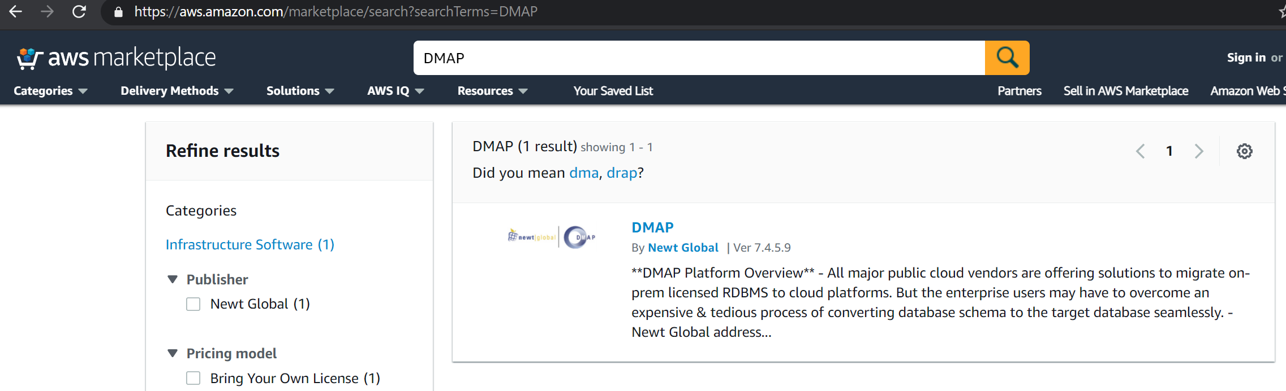

- Click “Continue to Subscribe” button

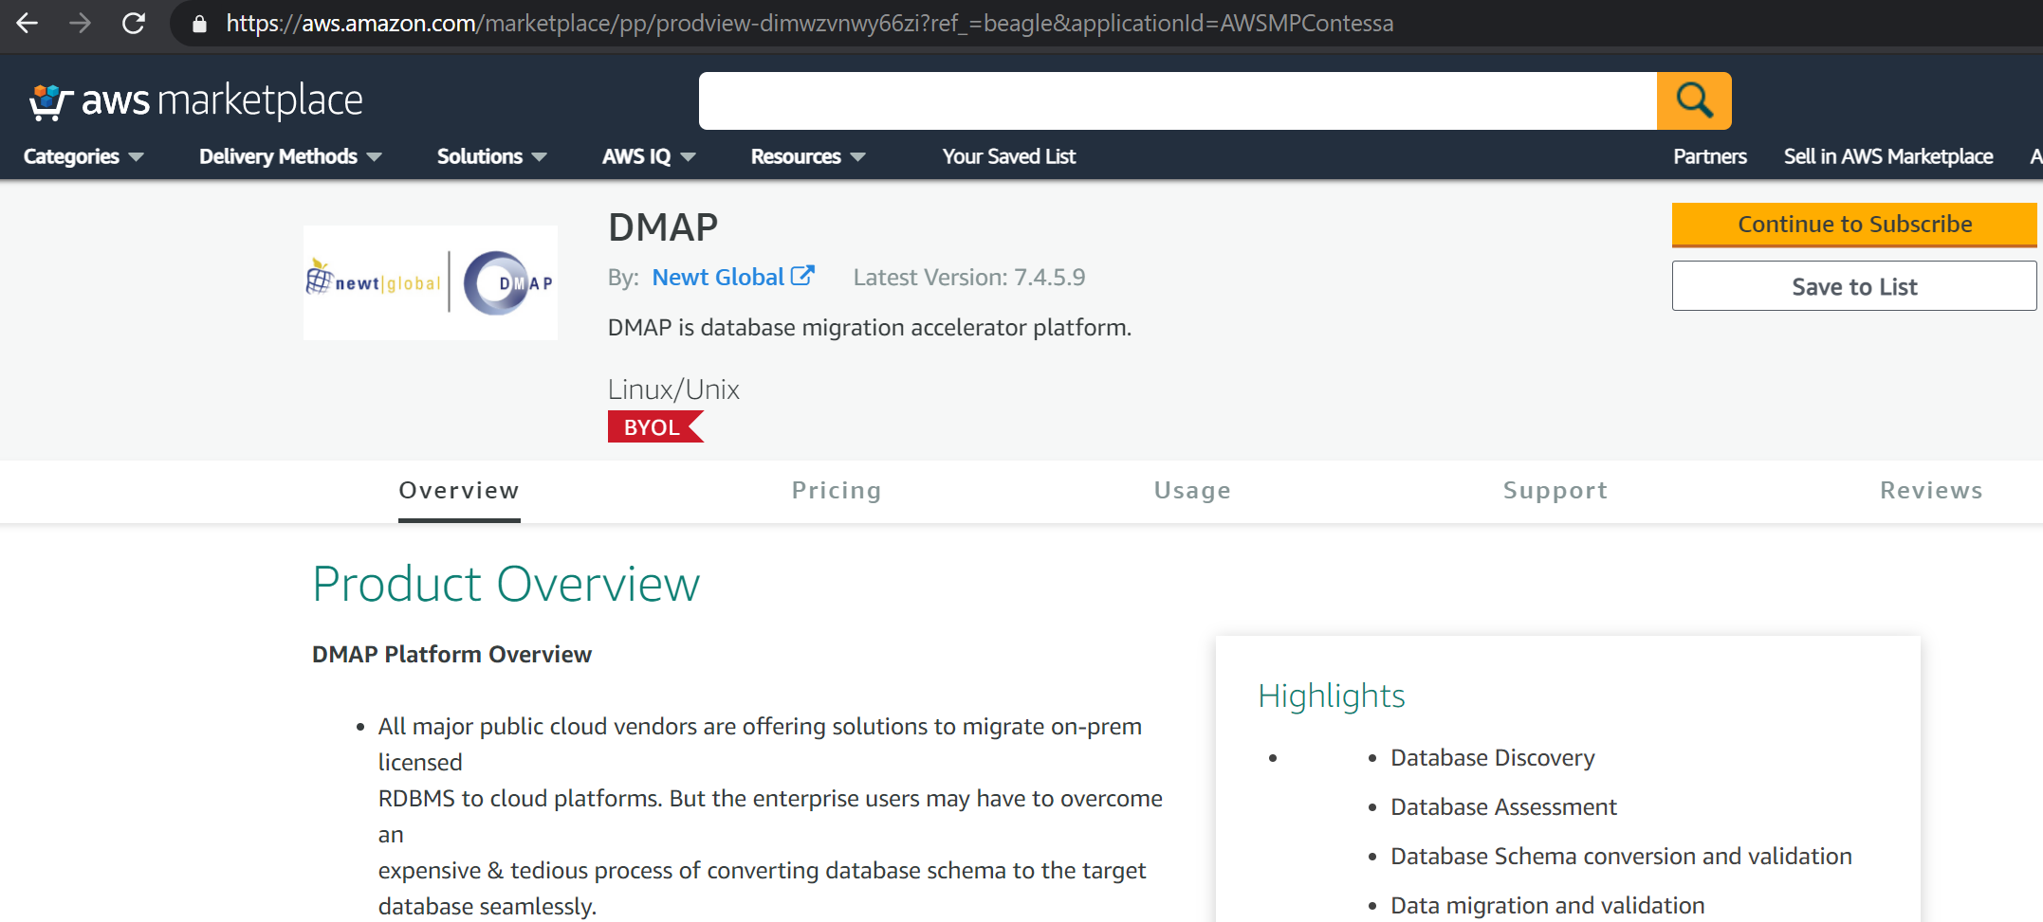

- If not logged in already, sign into AWS console – https://console.aws.amazon.com

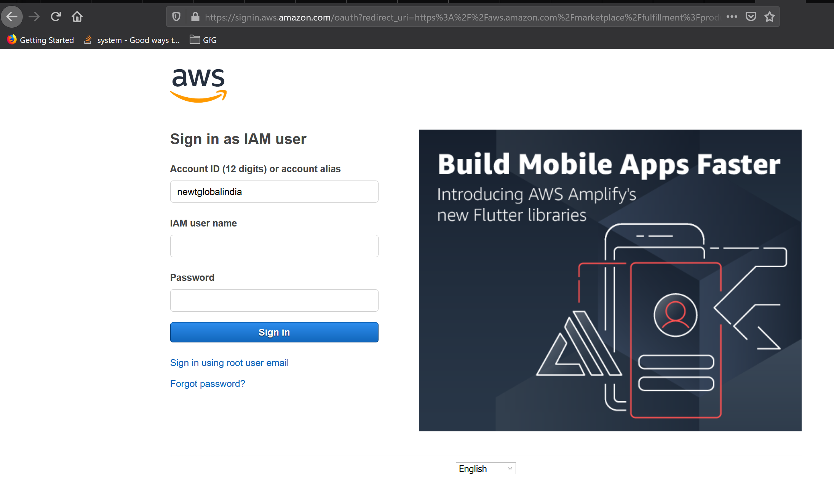

- Click “Accept Terms” button
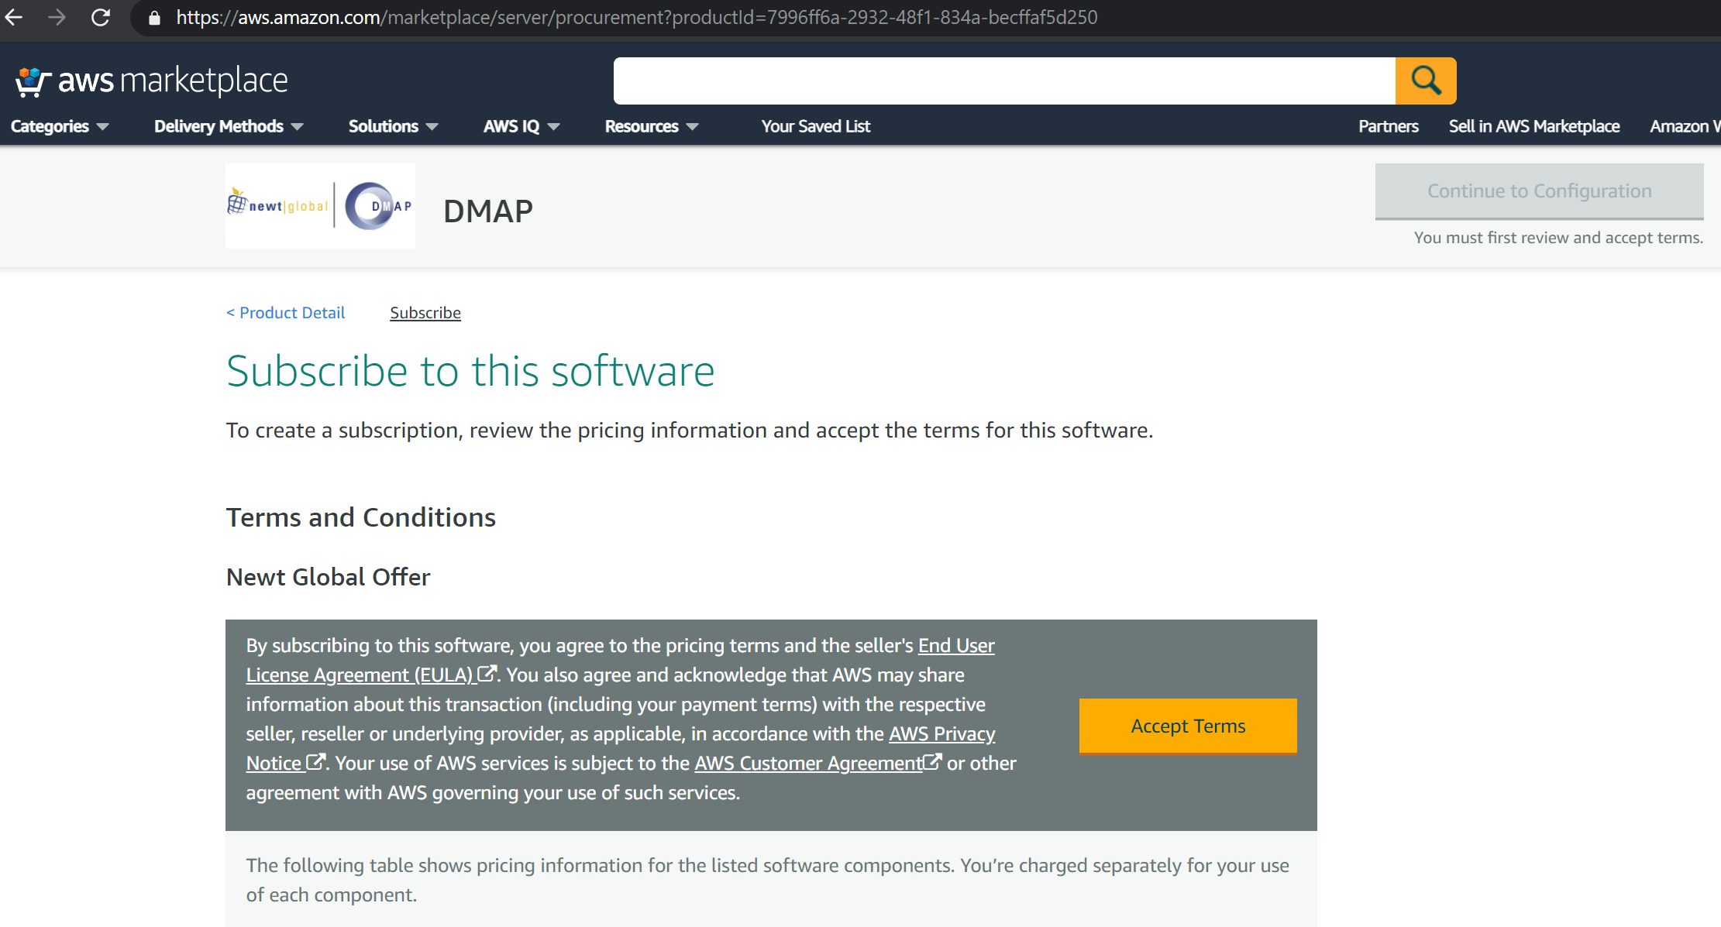

- Click “Continue to Configuration” button

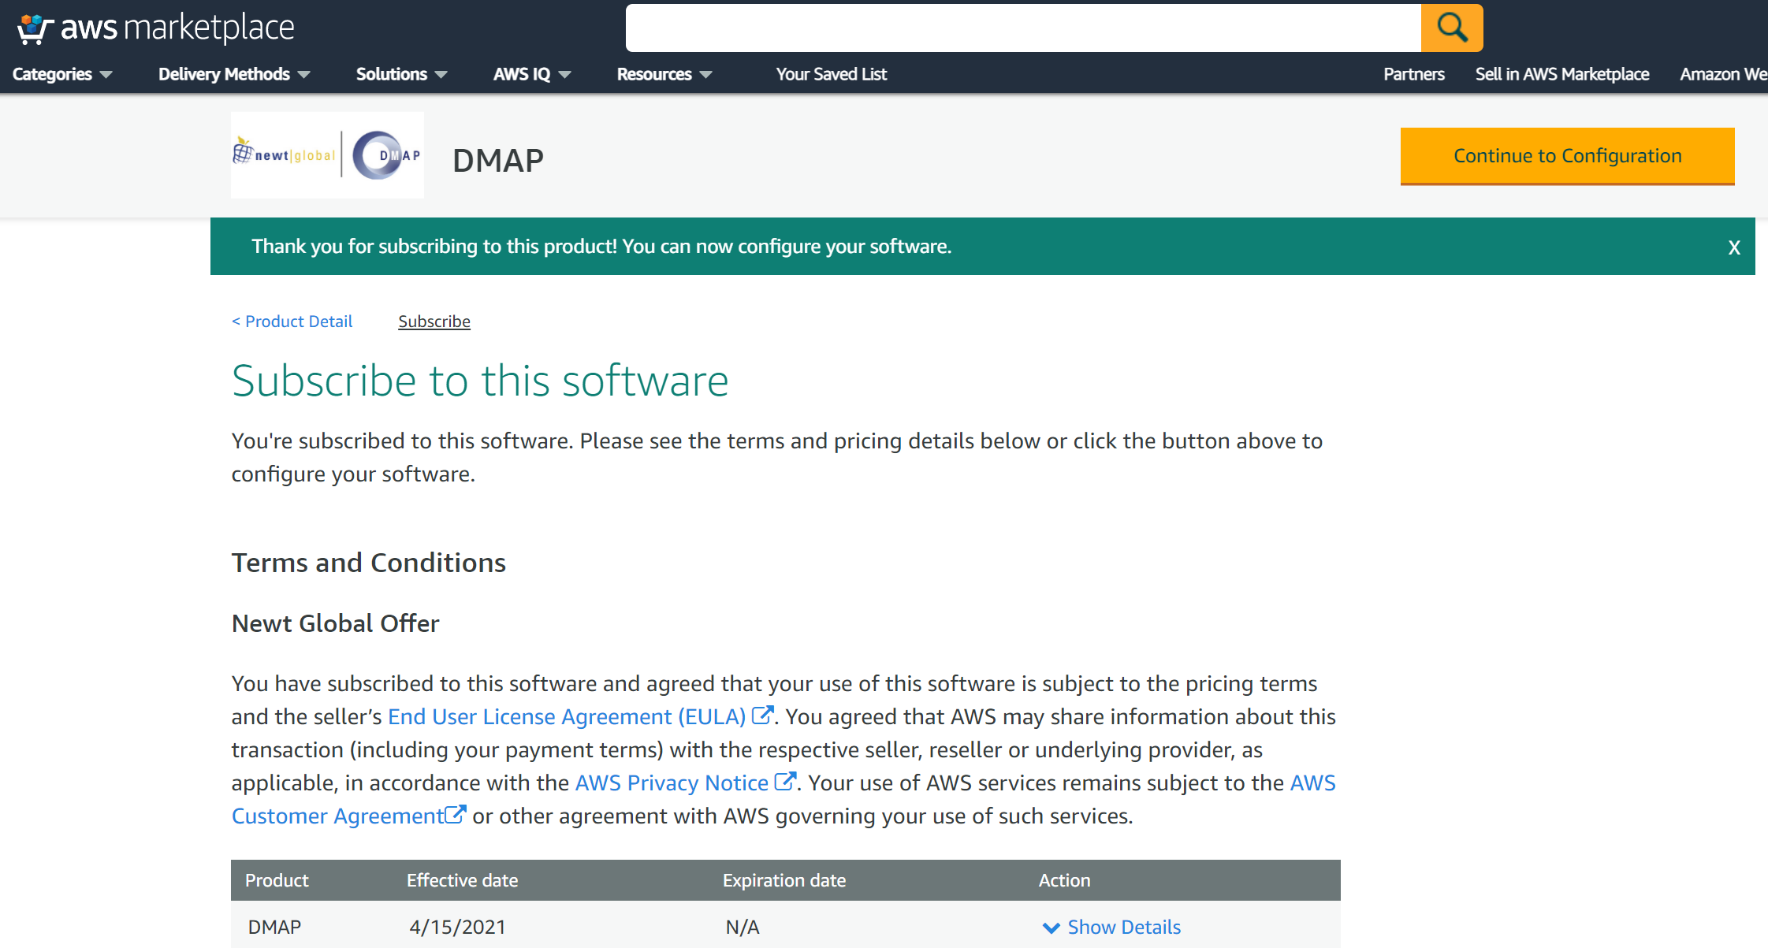

- Click “Continue to Launch” button

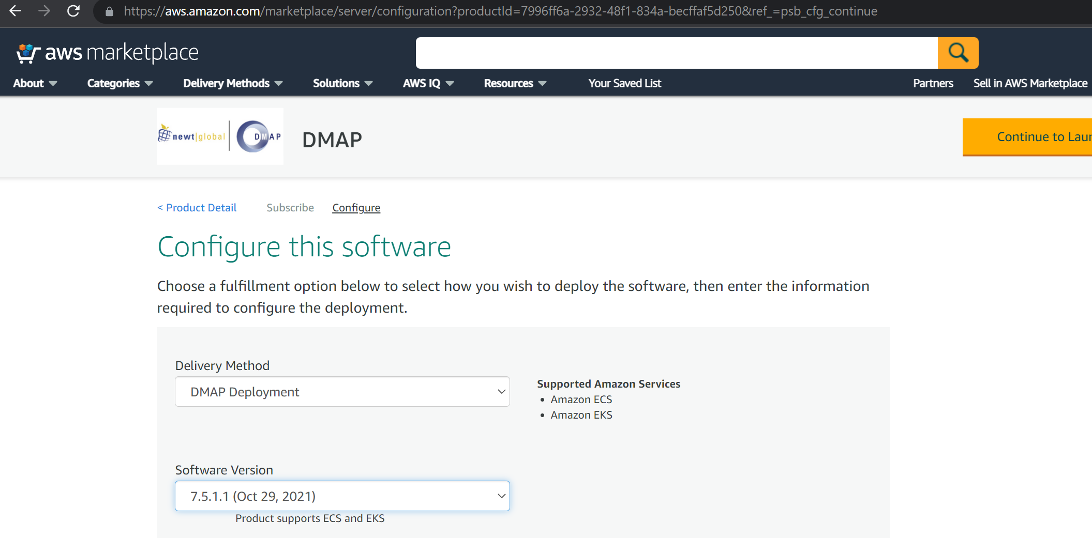

- Click “View container image details” link available at the bottom,

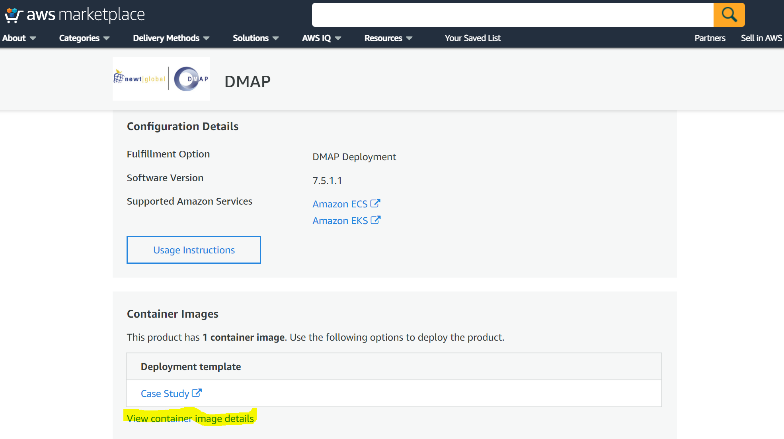

- From the popup, copy login command to authenticate your Docker client to your registry

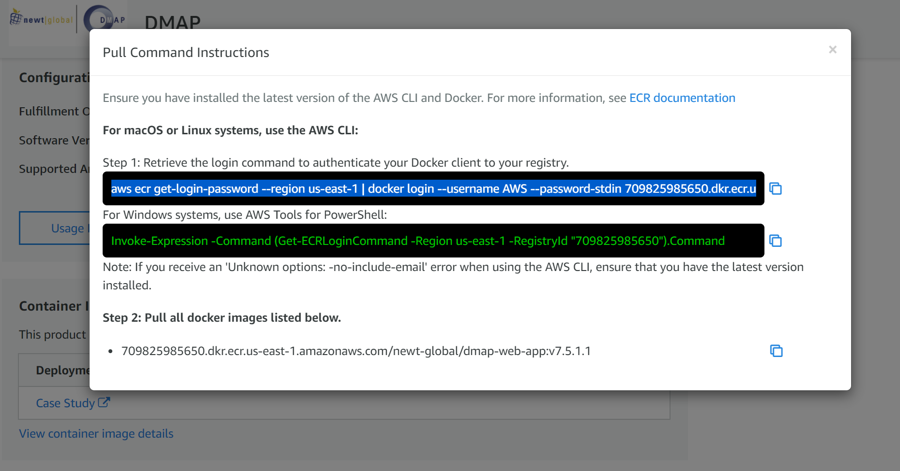

NOTE: Before moving to next step, make sure AWS CLI is installed and is configured with access key and secret access key. If not, refer Appendix section AWS Configure to configure keys to access AWS services from the command prompt or terminal.
- Run the copied command in your local Terminal, we should get “Login Succeeded” as response like below

- From the popup, copy the image name as below

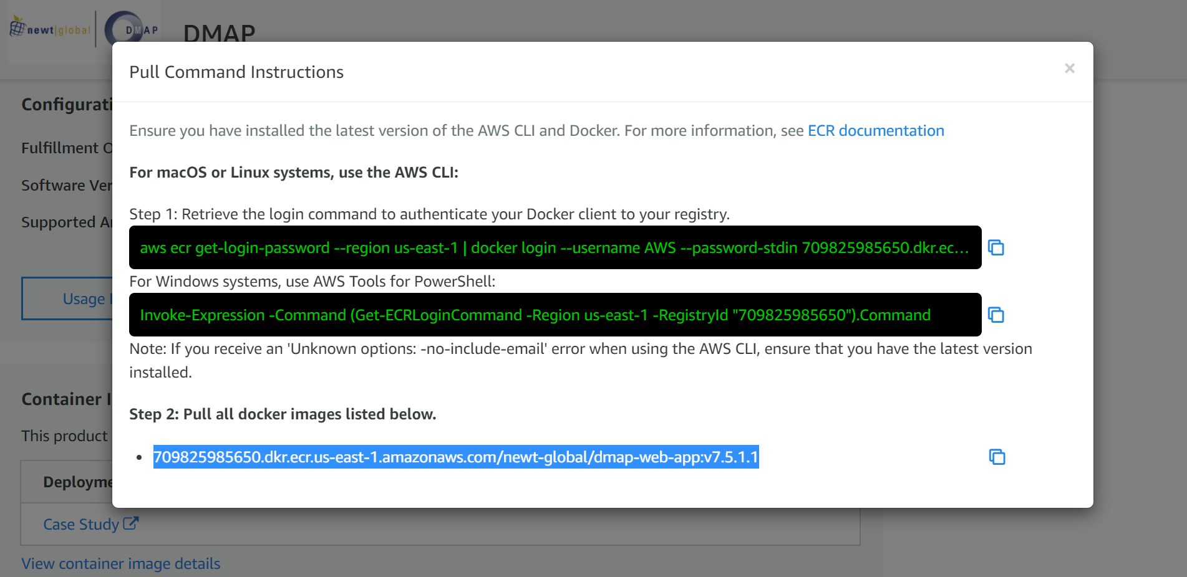

- To pull the DMAP docker image, run the below command on terminal
docker pull <<copied_image_name_from_the_pop_up>>
- To verify the downloaded image, run the below command on terminal
docker images

Create Repository in Elastic Container Registry (ECR)
Create a repository in ECR to which DMAP docker image will be pushed and stored.
Follow below steps to create a repository for DMAP.
- Go to AWS console and select Elastic Container Registry (ECR) service
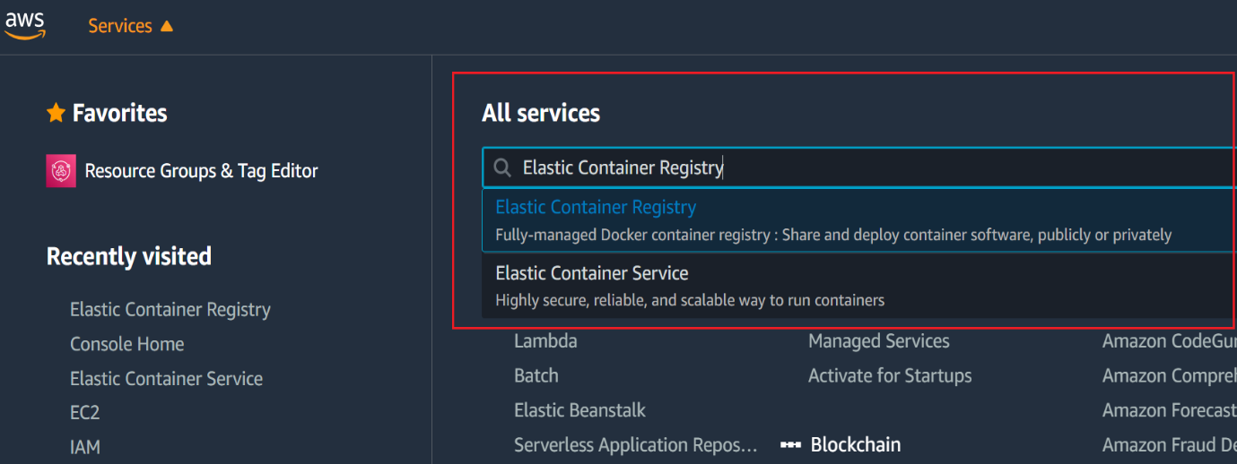
- In ECR repositories screen, choose private and click “Create repository”
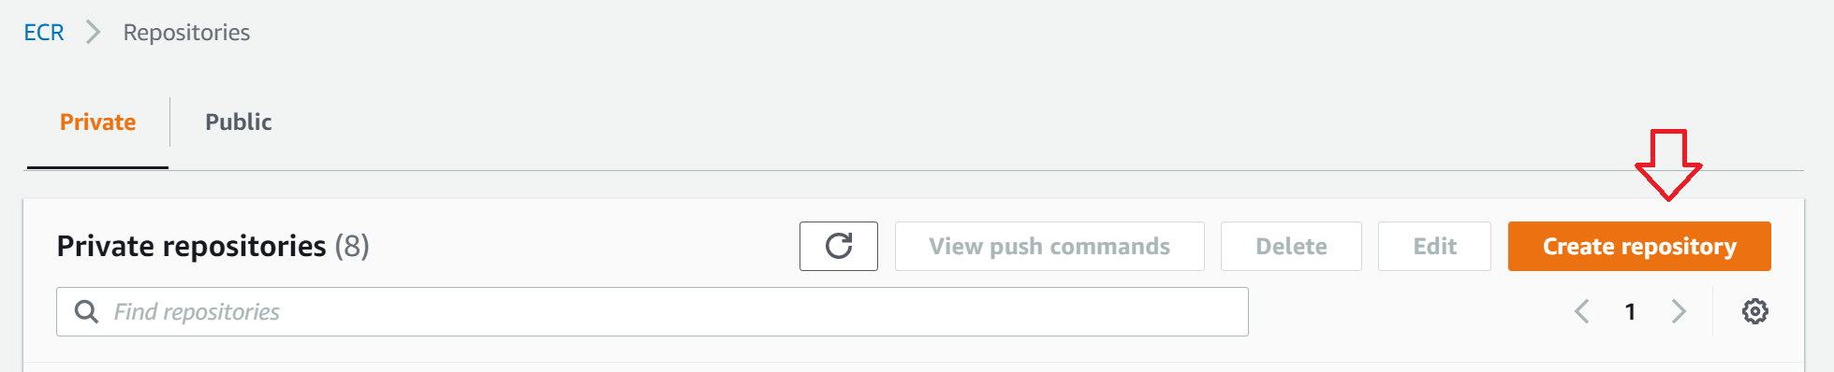

- Choose visibility as Private and enter a name for DMAP repository.
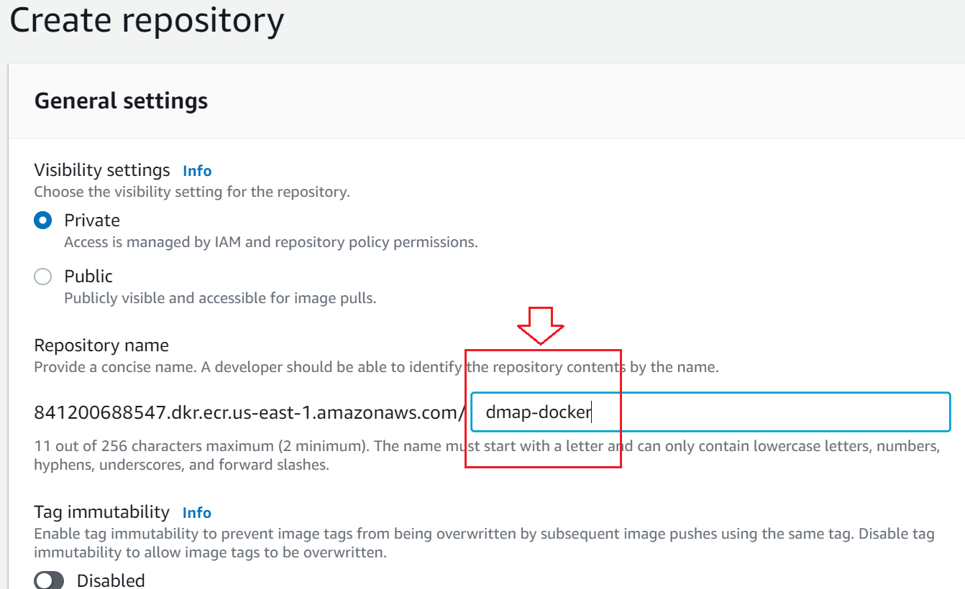

- You can leave other fields with default settings and click on Create repository button to create the repository
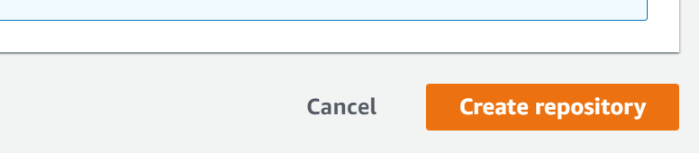

- Verify the created repository exist in the list
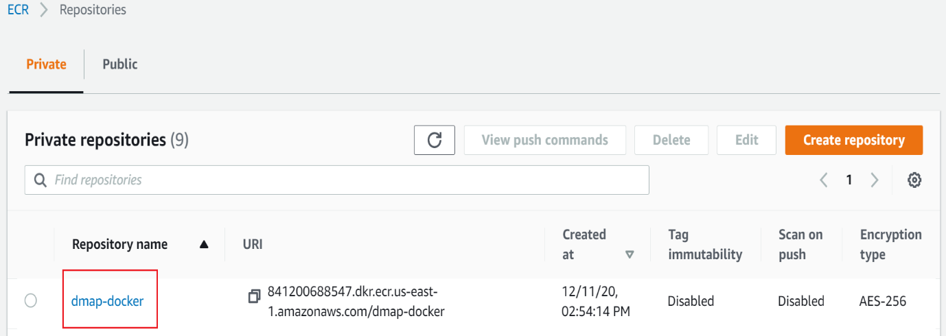

Upload downloaded DMAP docker image into ECR
Follow below steps to upload DMAP docker image into ECR
NOTE: Before moving to next step, make sure AWS CLI is installed and is configured with access key and secret access key. If not, refer Appendix section AWS Configure to configure keys to access AWS services from the command prompt or terminal.
- To login into ECR, go to terminal or command prompt and type command as
aws ecr get-login-password --region <<??REGION??>> | docker login --username AWS --password-stdin <<??ACCOUNTID??>>.dkr.ecr. <<??REGION??>>.amazonaws.com
- <<??REGION??>> - region where repository is created
- <<??ACCOUNTID??>> - AWS account id. It can be retrieved from the console as below
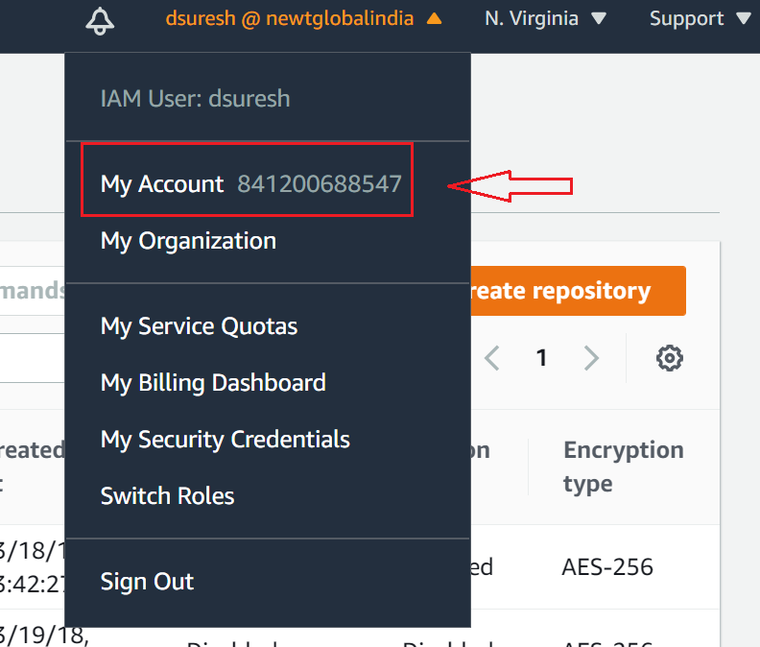
Sample command:
aws ecr get-login-password --region us-east-1 | docker login --username AWS --password-stdin 841200688547.dkr.ecr.us-east-1.amazonaws.com

- Once successfully logged in, command prompt will show Login Succeeded message.
- Tag the downloaded DMAP docker image (from Marketplace in Section 4) with ECR repo and tag detail. Run the below command on terminal or command line.
docker tag <<copied_image_name_from_the_pop_up>> <<??ACCOUNTID??>>.dkr.ecr.<<??REGION??>>.amazonaws.com/<<??REPO_NAME??>>:latest
- <<copied_image_name_from_the_pop_up>> - image name copied (retrieved) from Marketplace
- <<??REGION??>> - region where repository is created
- <<??ACCOUNTID??>> - AWS account id
- <<??REPO_NAME??>> - repository name
Sample command:
docker tag 709825985650.dkr.ecr.us-east-1.amazonaws.com/newt-global/dmap-web-app:v7.5.1.1 841200688547.dkr.ecr.us-east-1.amazonaws.com/dmap-docker:latest
- Run the below command on terminal or command line to Push the image to ECR.
docker push <<??ACCOUNTID??>>.dkr.ecr. <<??REGION??>>.amazonaws.com/<<??REPO_NAME??>>:latest
- <<??REGION??>> - region where repository is created
- <<??ACCOUNTID??>> - AWS account id
- <<??REPO_NAME??>> - repository name

Sample command:
docker push 841200688547.dkr.ecr.us-east-1.amazonaws.com/dmap-docker:latest
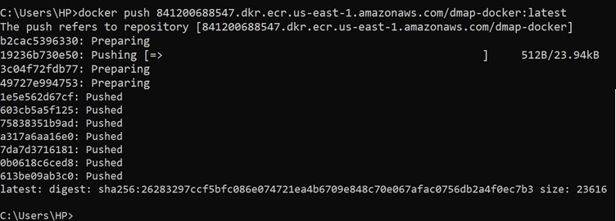

- Verify the uploaded image in the ECR. Go to Repositories and select the repository to which image was pushed.
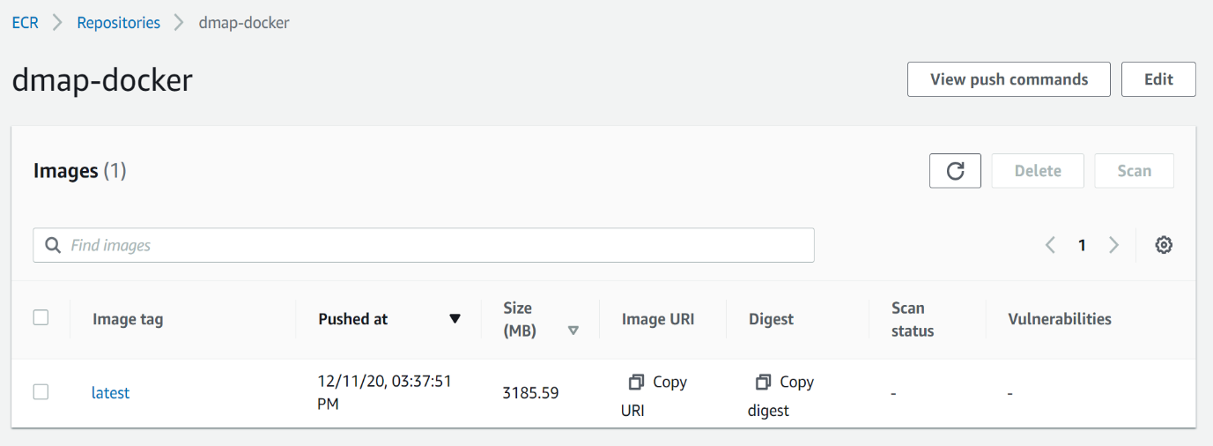

DMAP Container Creation
DMAP Docker image is installed and configured in a docker container running on one of the following:
- Container running in Elastic Container Service (ECS)
- Container running in user’s workstation

Creating container in Elastic Container Service (ECS)

7.1.1. Create ECS Cluster / Define Task Definition / Run Task (DMAP)
Follow below steps to create ECS cluster, define Task definition and run Task (deploy and run DMAP app)
- Go to AWS console and select Elastic Container Service (ECS)
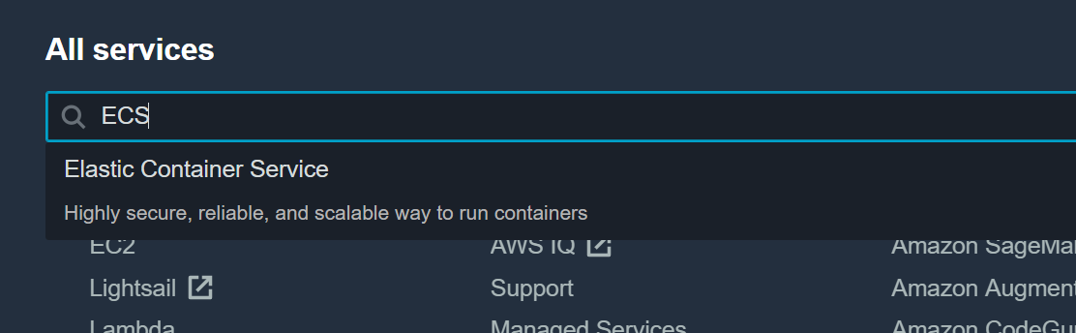
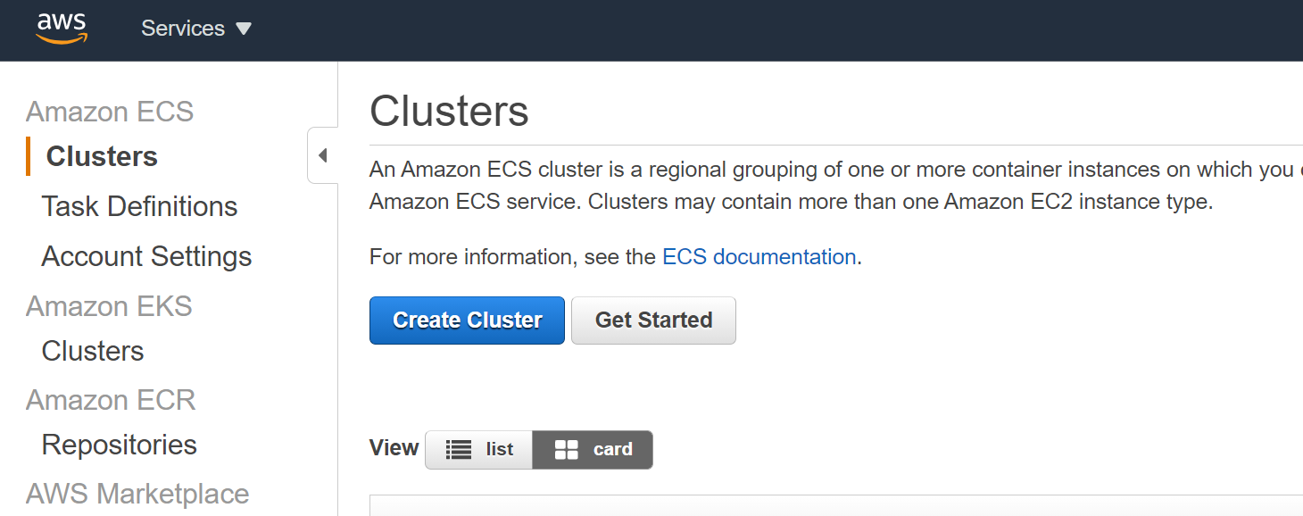

- In ECS Clusters screen, click “Create Cluster” button
- In Create Clusters screen, select “EC2 Linux + Networking” option and click “Next step” button. If can also chose other options as per your requirements.
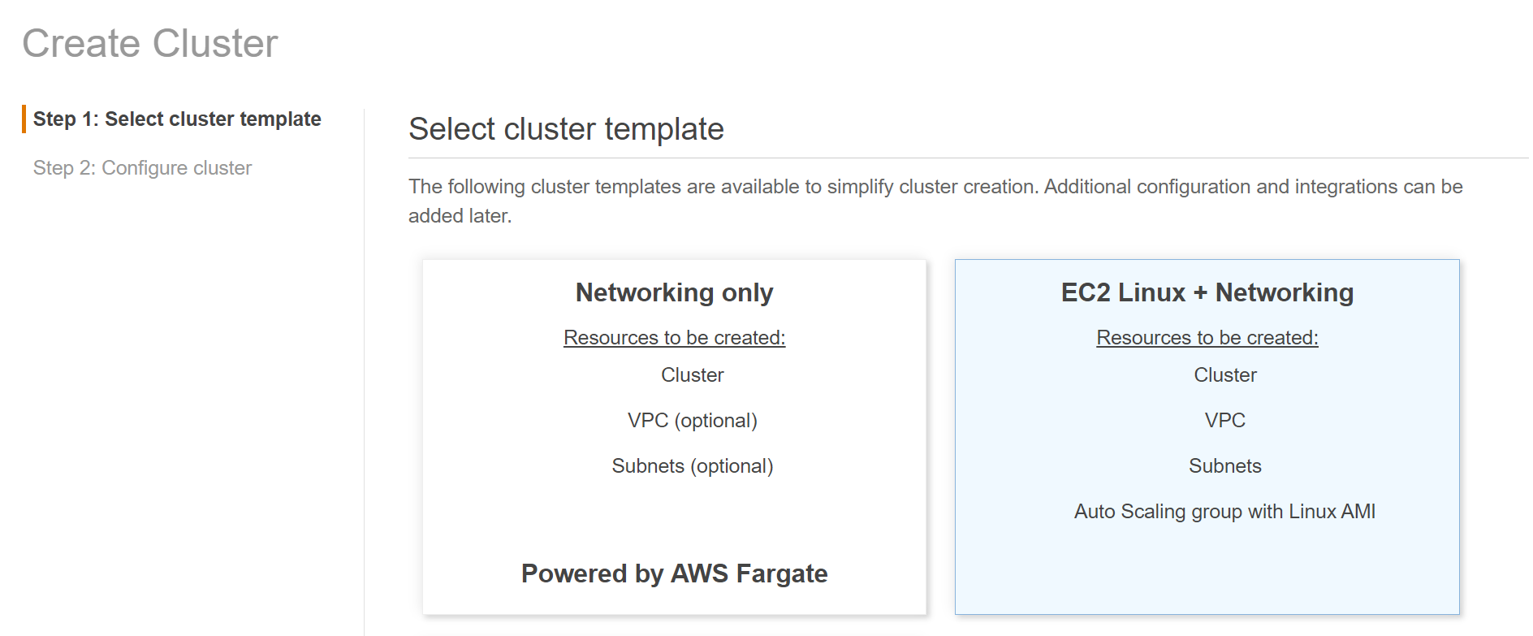

- In the Next Step enter necessary details.
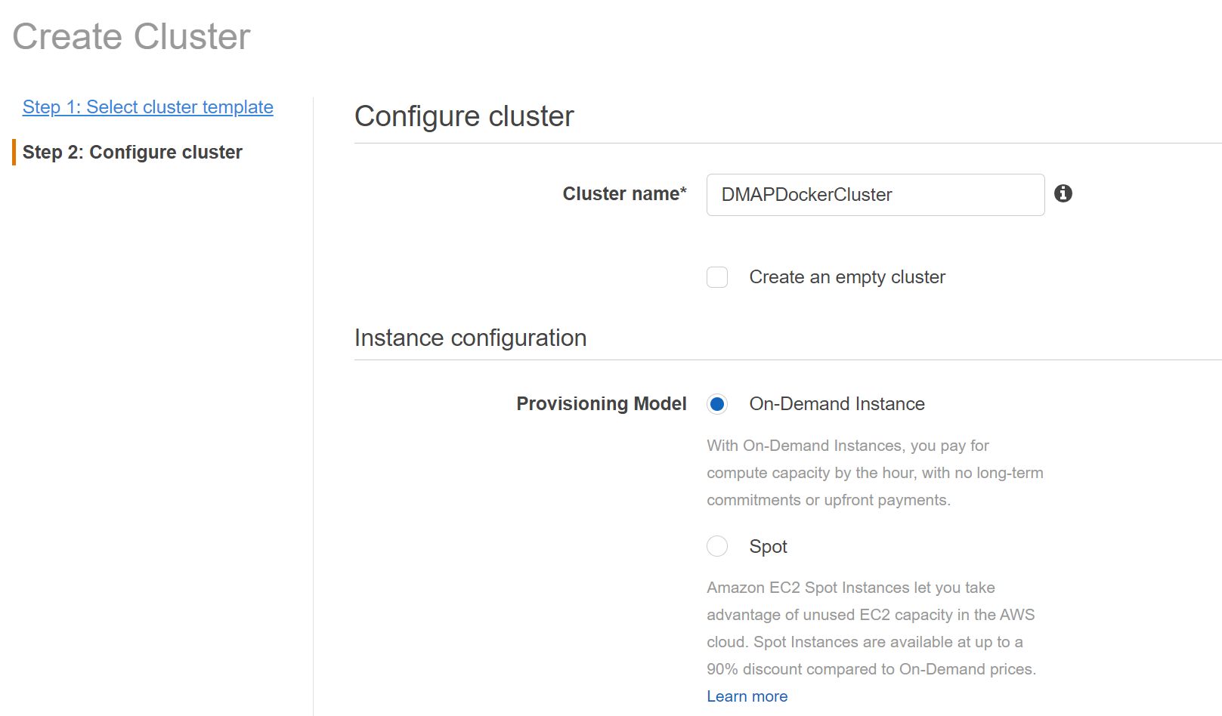

Key fields to note here are,

Field | Description
Cluster name | The name to use for your cluster. Choose a unique name.
EC2 instance type | The instance type to use for your container instances. The instance type that you select determines the resources available for your tasks to run on.
Number of instances | The number of instances to launch into your cluster.
Root EBS Volume Size (GiB) | The size of the root EBS volume. By default, the ECS-Optimized AL2 AMI launches with a 30 GiB root volume. You can increase the size of the data volume to allow for greater image and container storage.
VPC | Choose an existing VPC for your container instances or create a new one.
Subnets | Choose an existing subnet for your container instances.
Auto assign public IP | Requests a public IP address from Amazon's public IP address pool, to make your instance reachable from the Internet. The public IP address is associated with the instance until it’s stopped, terminated, hibernated, or assigned an Elastic IP address, after which it’s no longer available for you to use.
Security group | Choose an existing security group for your container instances or select Create a new security group to create a new one.  Key to note here is the selected security group should have inbound rule with ports 8080 and 5002 enabled for public access. To know more, check note in the following details.

- After entering necessary details, click “Create” button.
- Once cluster is created, success message will be displayed as shown below. Now click on “View Cluster” button.

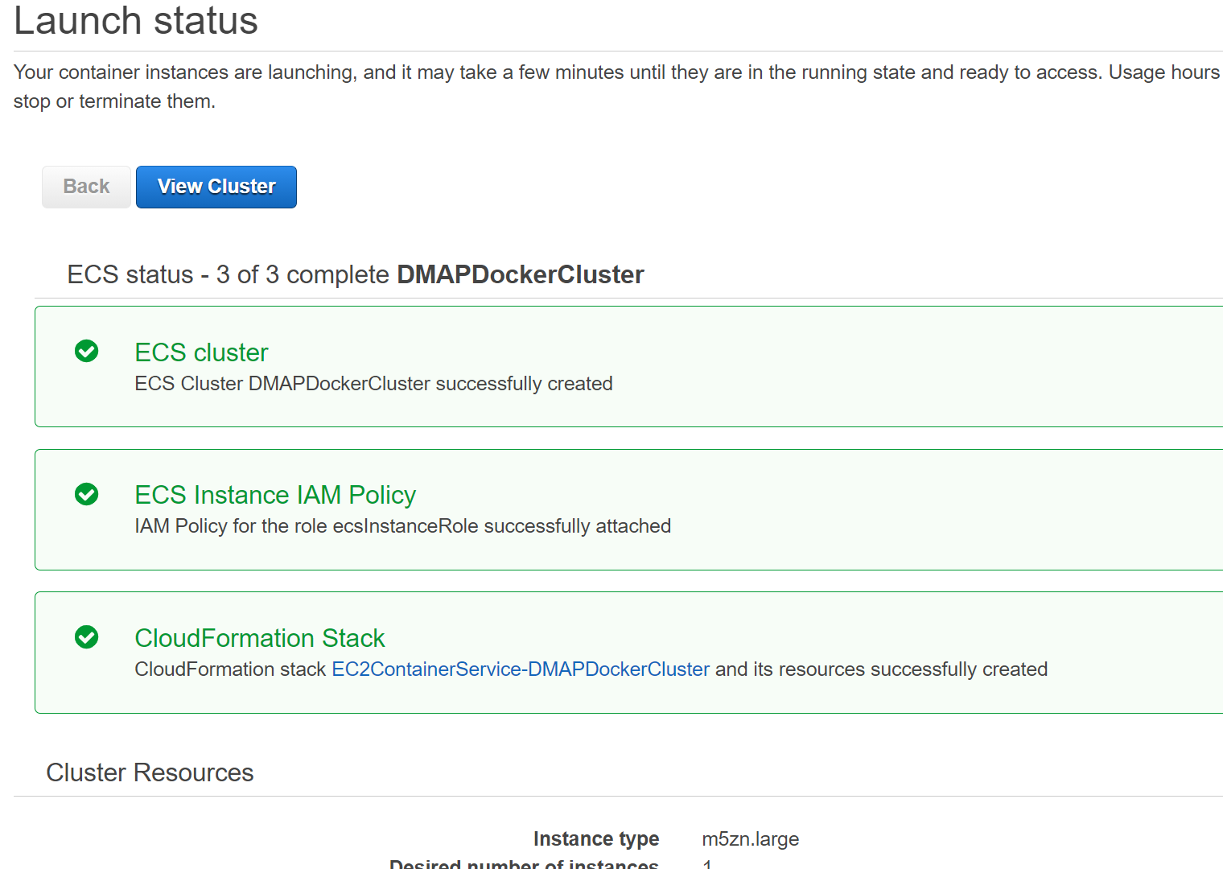

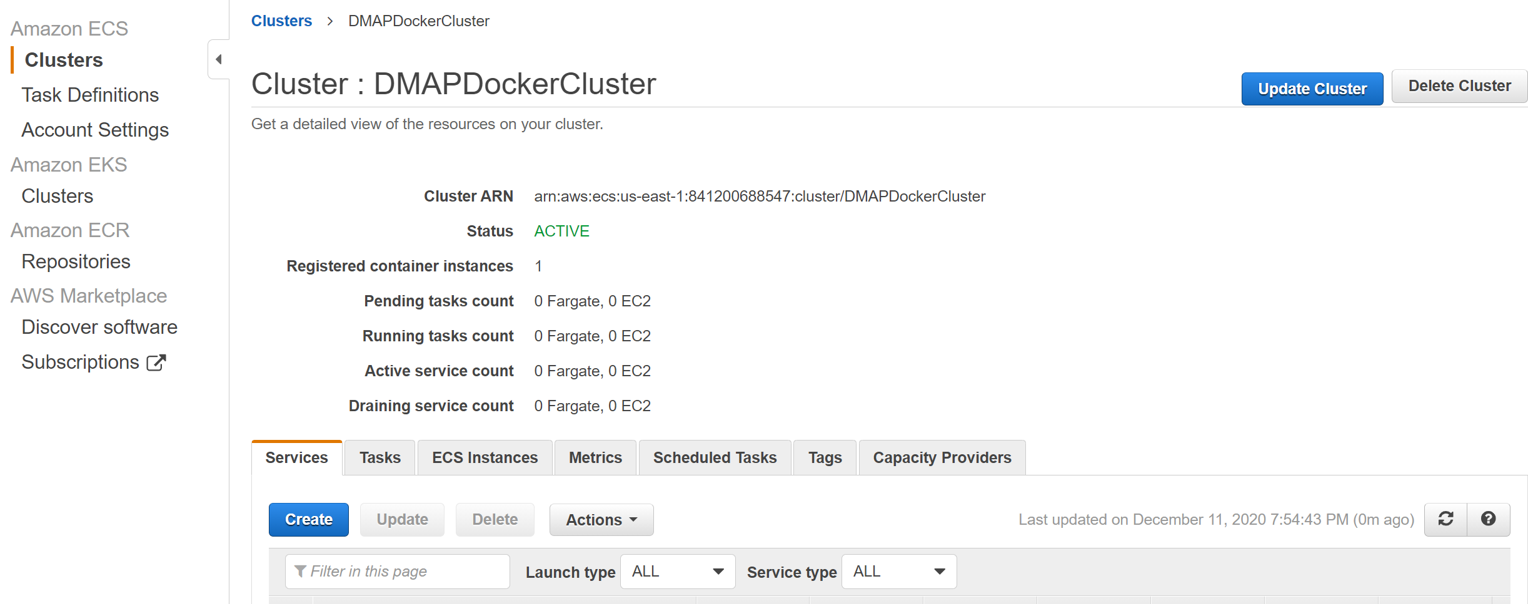
- To verify newly created EC2 instance, go to EC2 services and filter running instances to verify EC2 instance for ECS has been created. This instance is a plain Linux instance running as part of ECS cluster and without DMAP application installed in it.

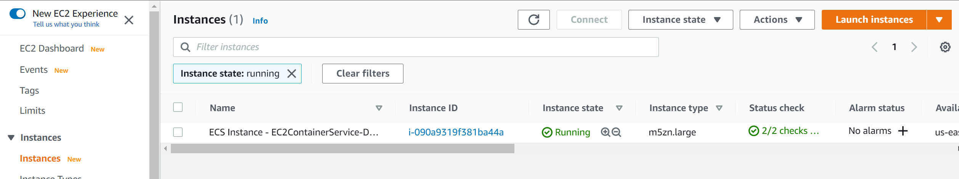

- NOTE: Make sure that host machine security group is configured with inbound rules by enabling ports such as 8080 and 5002 to allow access from outside world. For that, select the security tab and click Security groups link as below.

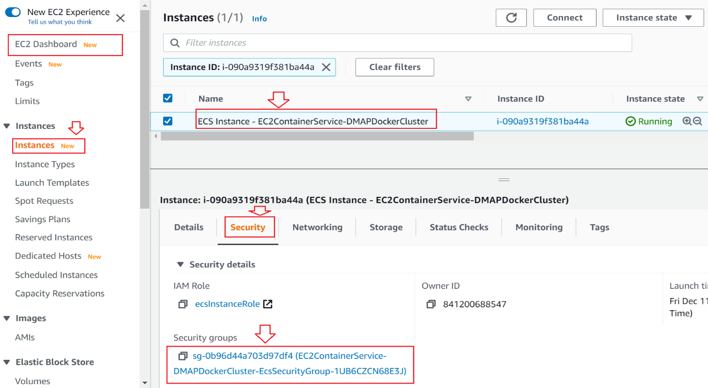
Click on Security Groups to navigate to Security group details screen.
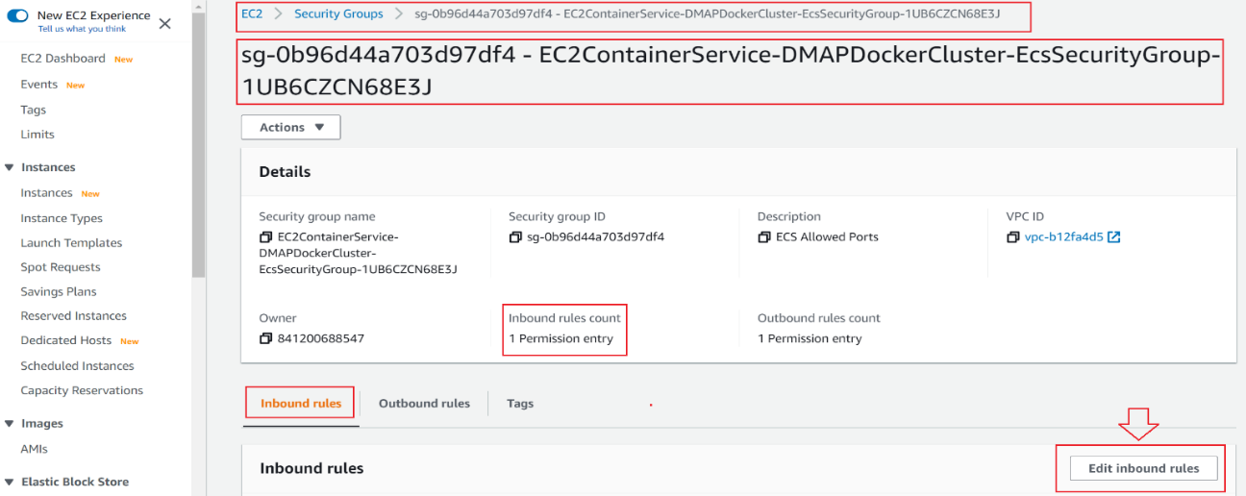

In the above screen, click on Edit inbound rules button to check or add new rules to allow DMAP required ports i.e., 8080 and 5002 to access from outside world.

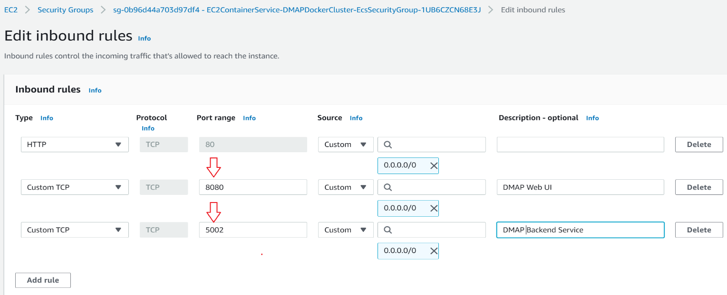

After entering above details, click on Save rules button.
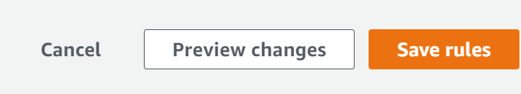
- To deploy DMAP docker image in the above created EC2 instance, go to ECS and select “Task Definitions”.
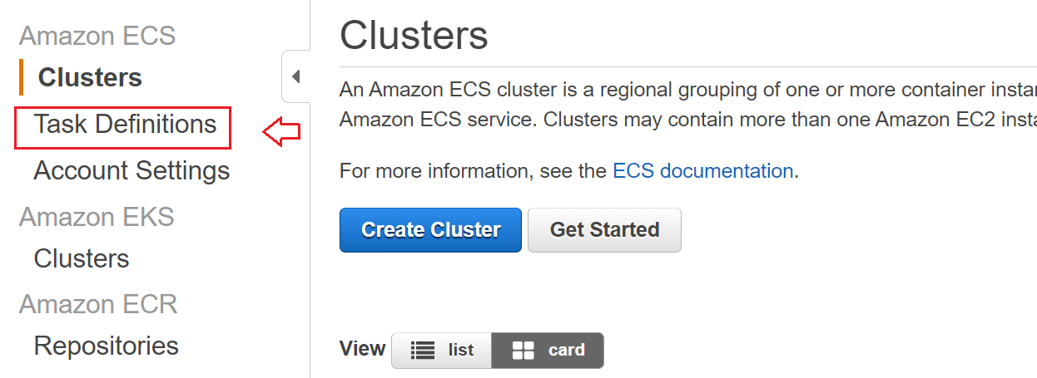

- Click “Create new Task Definition” button to define task to specify docker image details to deploy and run.
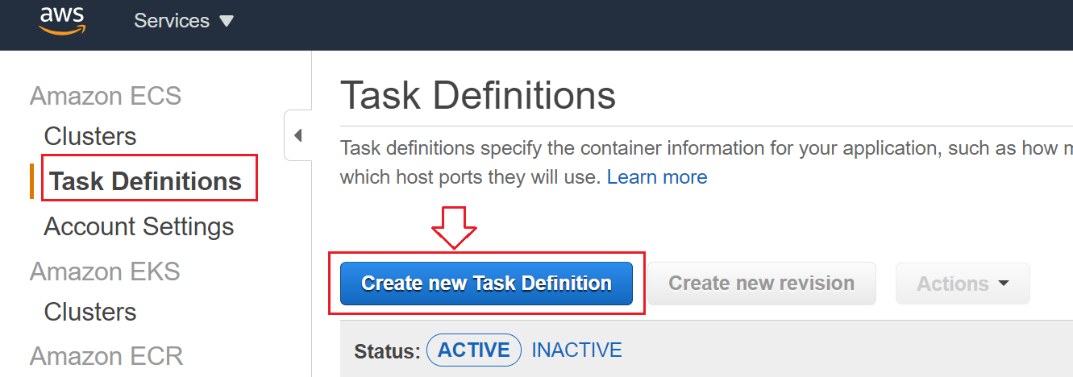

- Select “EC2” and click “Next step”.
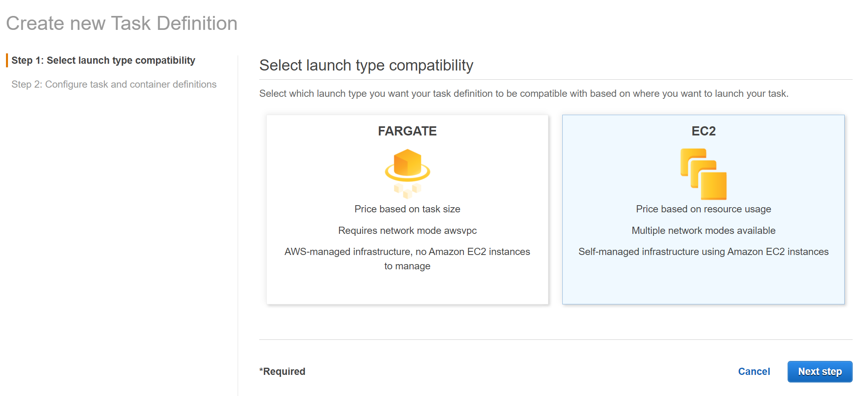
- In the Next Step enter necessary details.
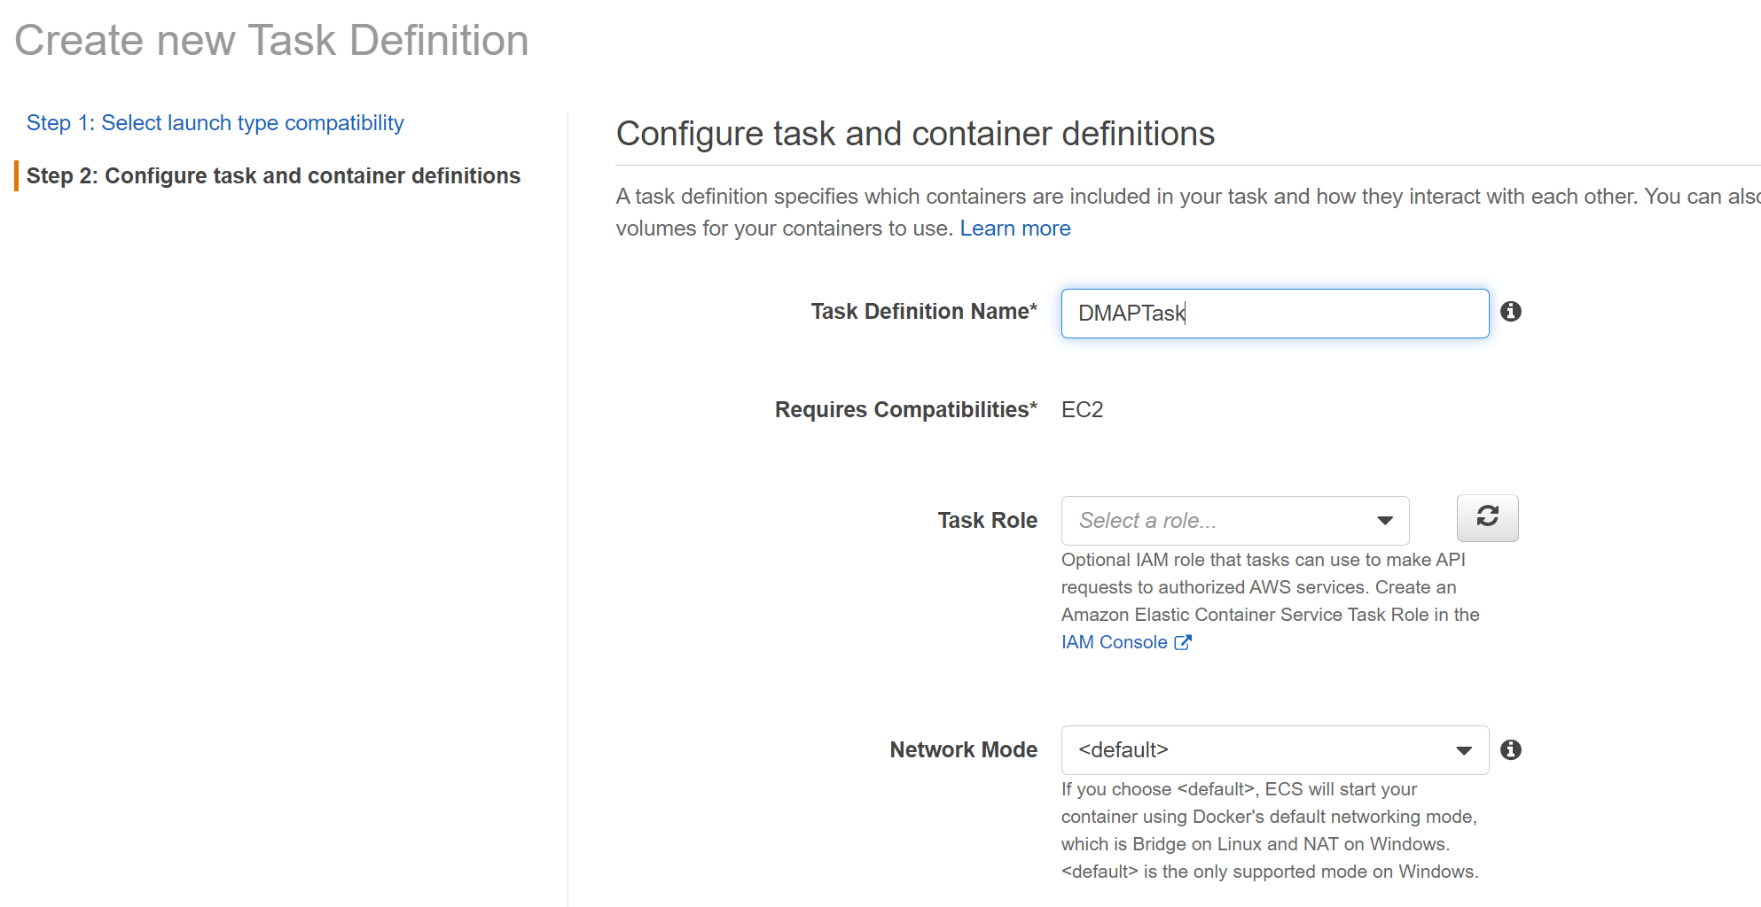

Key fields to note in Task Definition screen are
Fields | Description
Task Definition Name | Specify a name for your task definition. Up to 255 letters (uppercase and lowercase), numbers, hyphens, and underscores are allowed.
Add Container (button) | Pop up screen to specify docker image details. Check below

- In the same screen, click “Add container” to mention docker image details
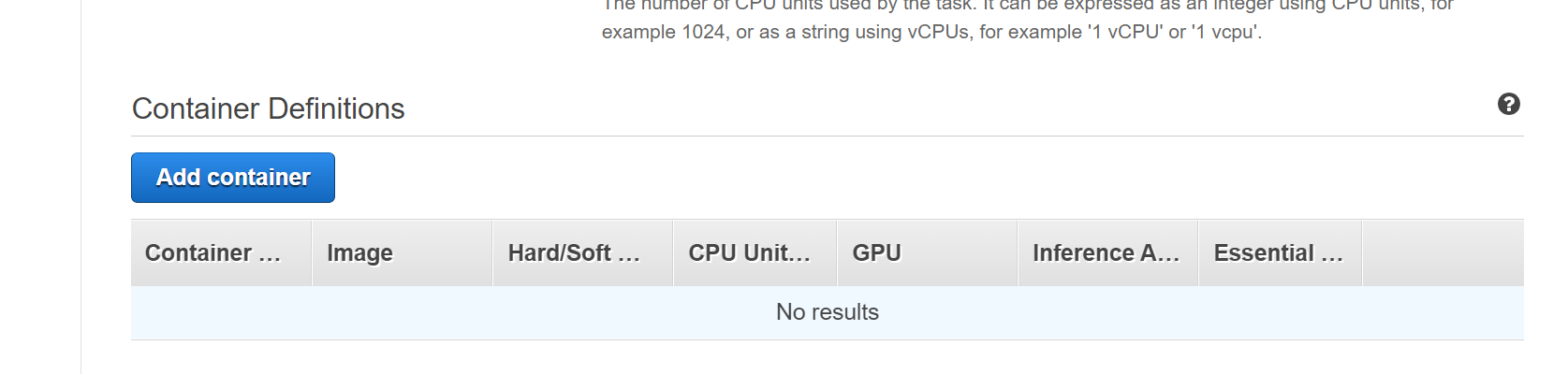
- In the “Add container” screen enter necessary details
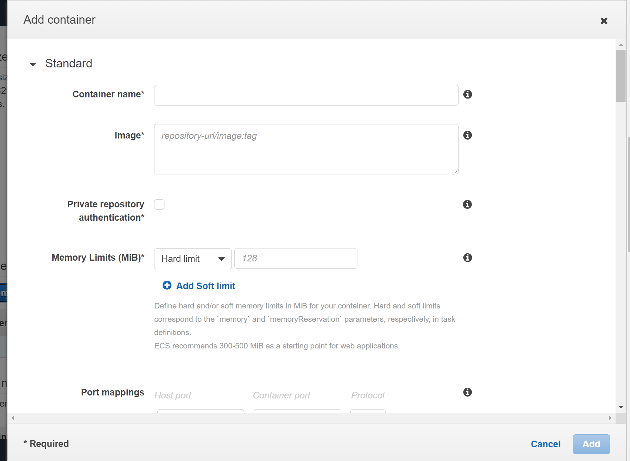
Key fields to note in Add Container screen are:

Fields | Description
Container name | The name of a container. Up to 255 letters (uppercase and lowercase), numbers, hyphens, and underscores are allowed.
Image | The image used to start your container. Up to 255 letters (uppercase and lowercase), numbers, hyphens, underscores, colons, periods, forward slashes, and number signs are allowed.  To get the image name, go to ECR screen and copy image URI like below and add tag at the end manually.  Sample:  841200688547.dkr.ecr.us-east-1.amazonaws.com/dmap-docker:latest
Memory Limits (MiB) | If you specify a hard limit (memory), your container will be killed if it attempts to exceed that limit. If you specify a soft limit (memoryReservation), ECS reserves that amount of memory for your container; however, the container can request up to the hard limit (if specified) or all the available memory on the container instance, whichever is reached first. If you specify both, the hard limit must be greater than the soft limit.  ECS recommends 300-500 MiB as a starting point for web applications.  Sample:  500
Port mappings | Port mappings allow containers to access ports on the host container instance to send or receive traffic.  For DMAP add 8080 and 5002 ports to be mapped with host.  Sample:  Host Port Container port Protocol  8080 8080 TCP  5002 5002 TCP  Above mapping enables that whenever user request host machine with port 8080 and 5002, request will be forwarded to container’s port 8080 and 5002, respectively.  Refer sample in the below image.

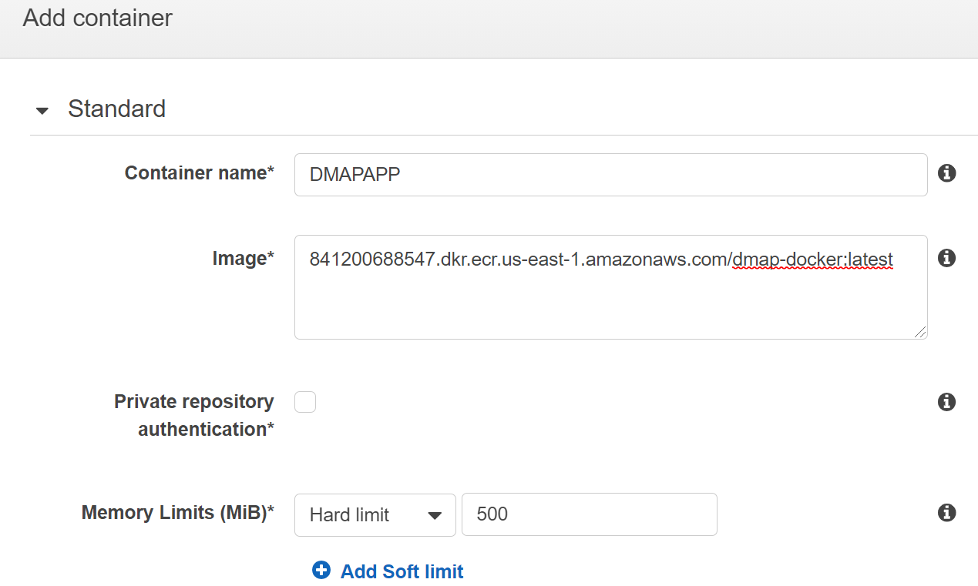
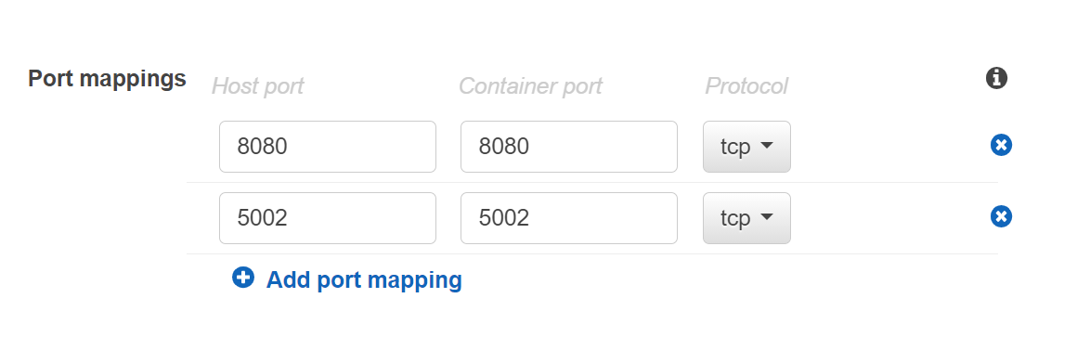

After providing necessary info, click “Add” button at the bottom.
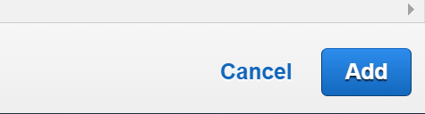
- Once container is added, in the previous Task definition screen, added container details will be displayed as below,
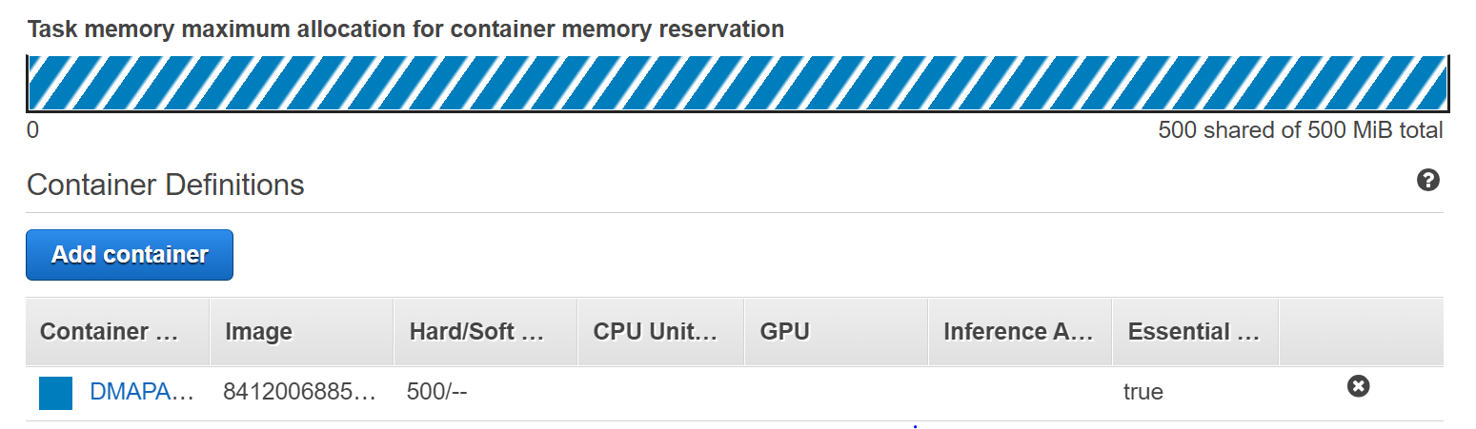
- After providing other necessary details in the Task definition screen, click “Create” button at the bottom.
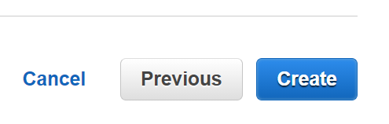
- Once created, success message will be displayed as shown below
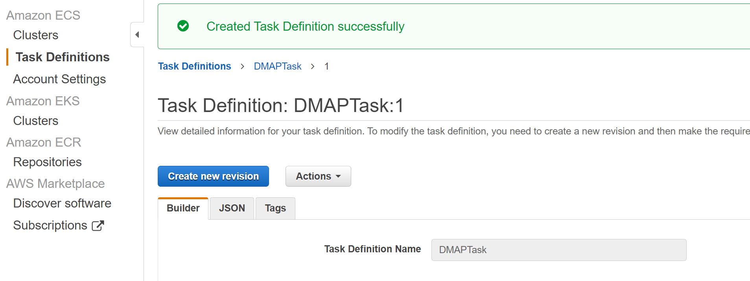

- Now to deploy and run DMAP image by running the defined task, in the created Cluster screen, go to “Tasks” tab and click “Run new Task” button to run the task as below.
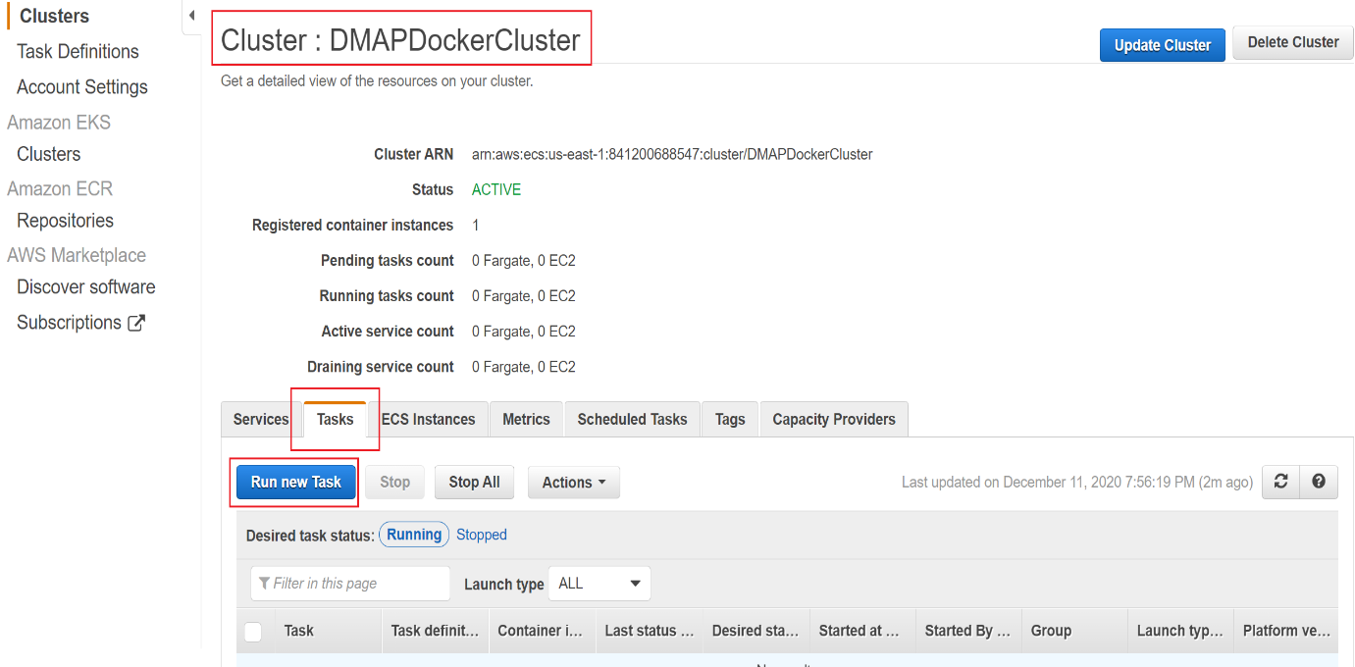
- In “Run Task” screen, enter necessary details.
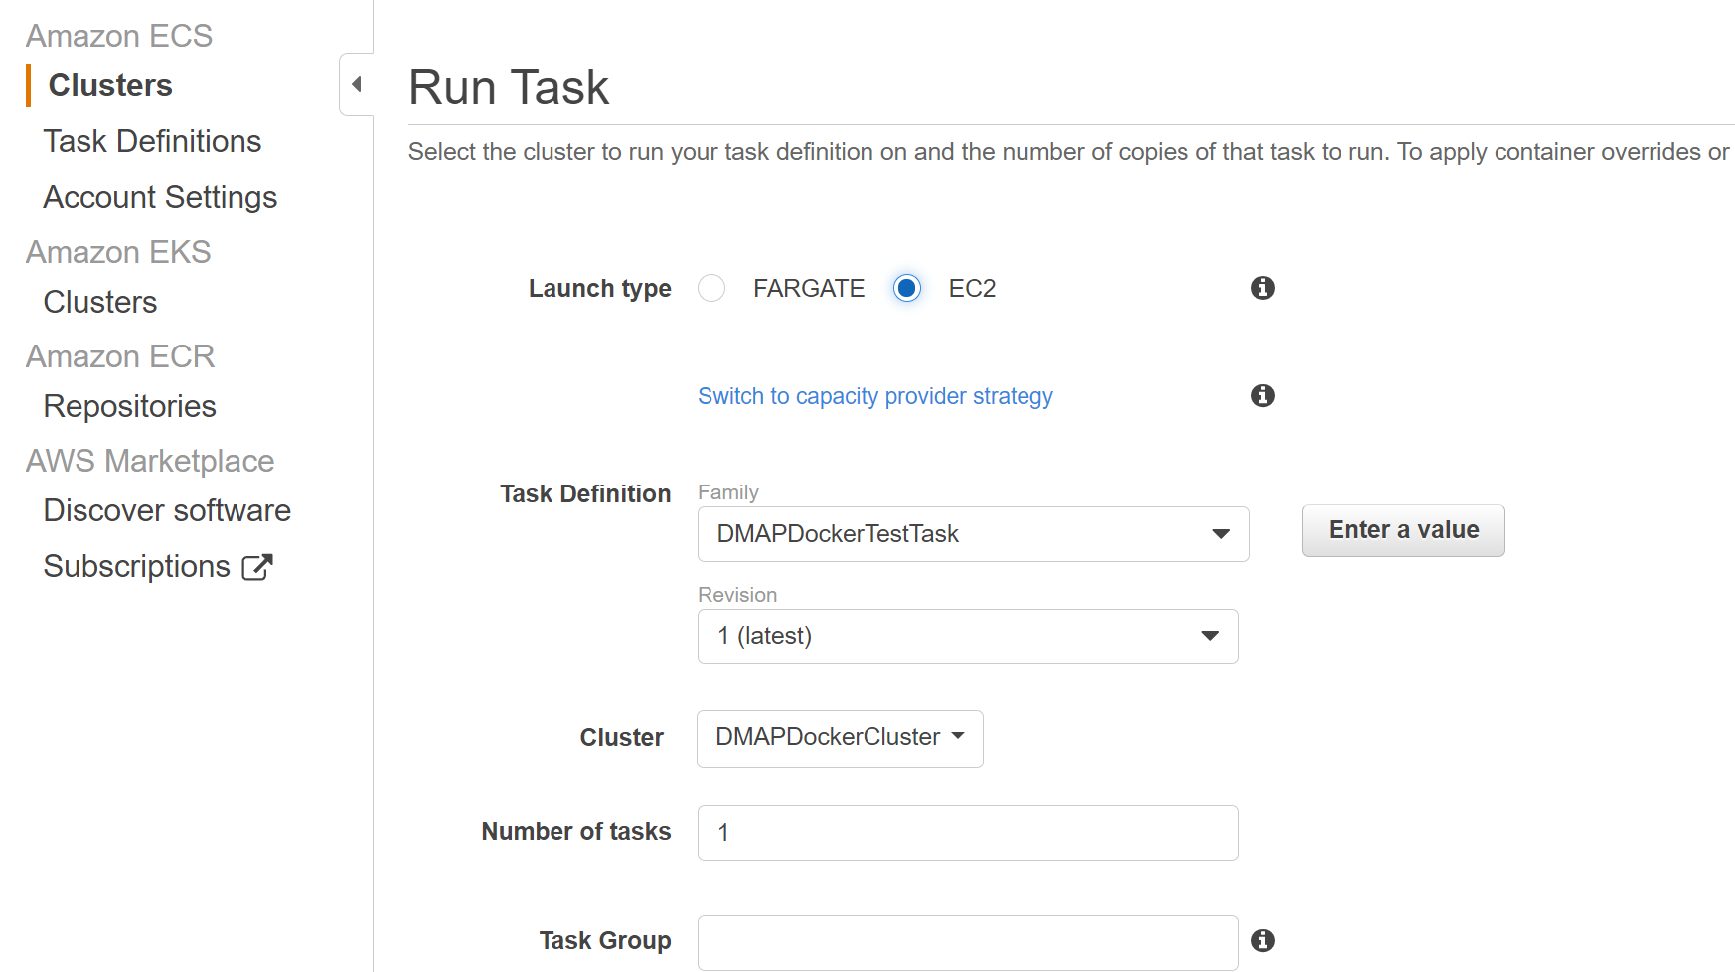
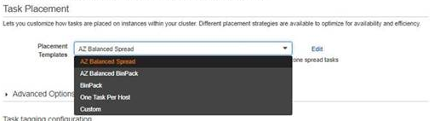
Key fields to note in Run Task screen are:
Fields | Description
Launch type | The launch type on which to run your task.  Select EC2 for our use case
Task Definition | Select the created Task definition
Placement Templates | Select One Task Per Host  This option will create one VM per container.

- After providing necessary details, click “Run Task” button at the bottom
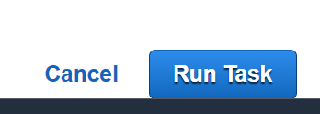
- To check the running task, go to “Tasks” tab and see the newly running task and its status as below.
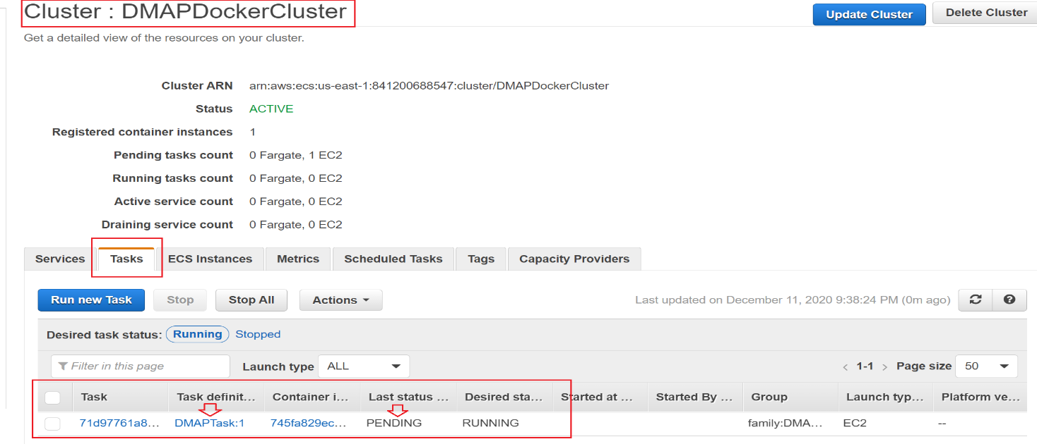
- Once last status is moved to “RUNNING” state, we are ready to access DMAP. But When DMAP container is started, it will download fresh binary files for GUI and backend services for the first time. In subsequent runs, it checks if a newer version is available and downloads it from AWS S3 storage. So, please wait for 5 – 15 minutes for DMAP to download these files and then proceed to next step to open the login page.

Accessing DMAP
To access DMAP, we need to know the public IP address of the Linux EC2 instance. To get it, go to created ECS cluster and select “ECS Instances” tab. From the running instance list, Click on the EC2 instance link. It will navigate to EC2 screen, from there get public IP address of that machine.

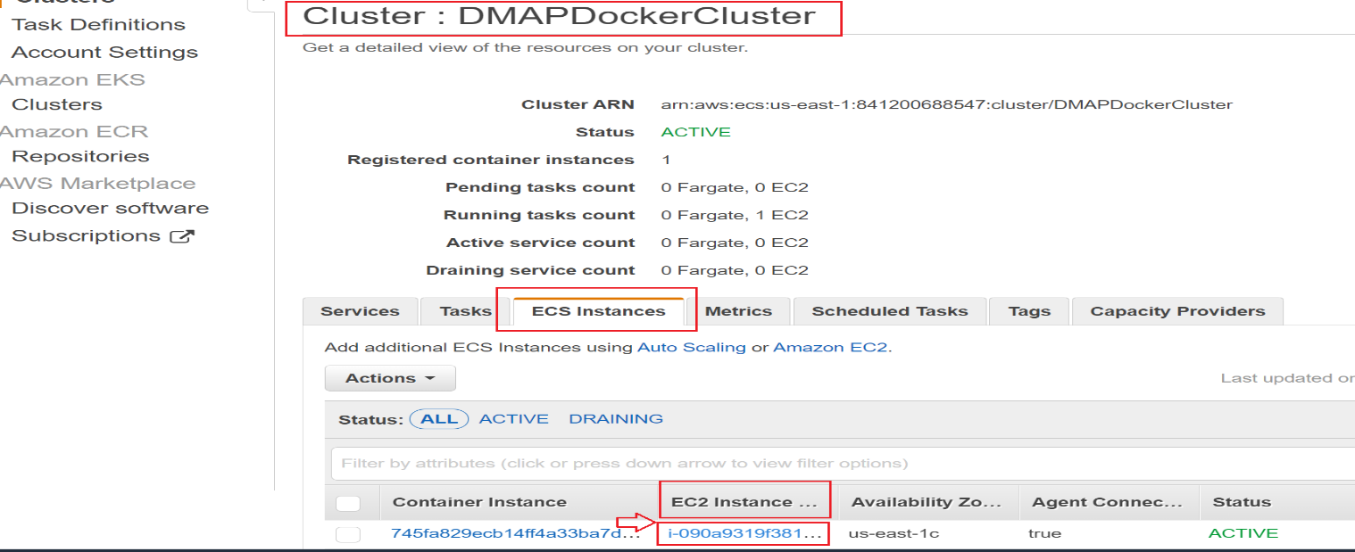
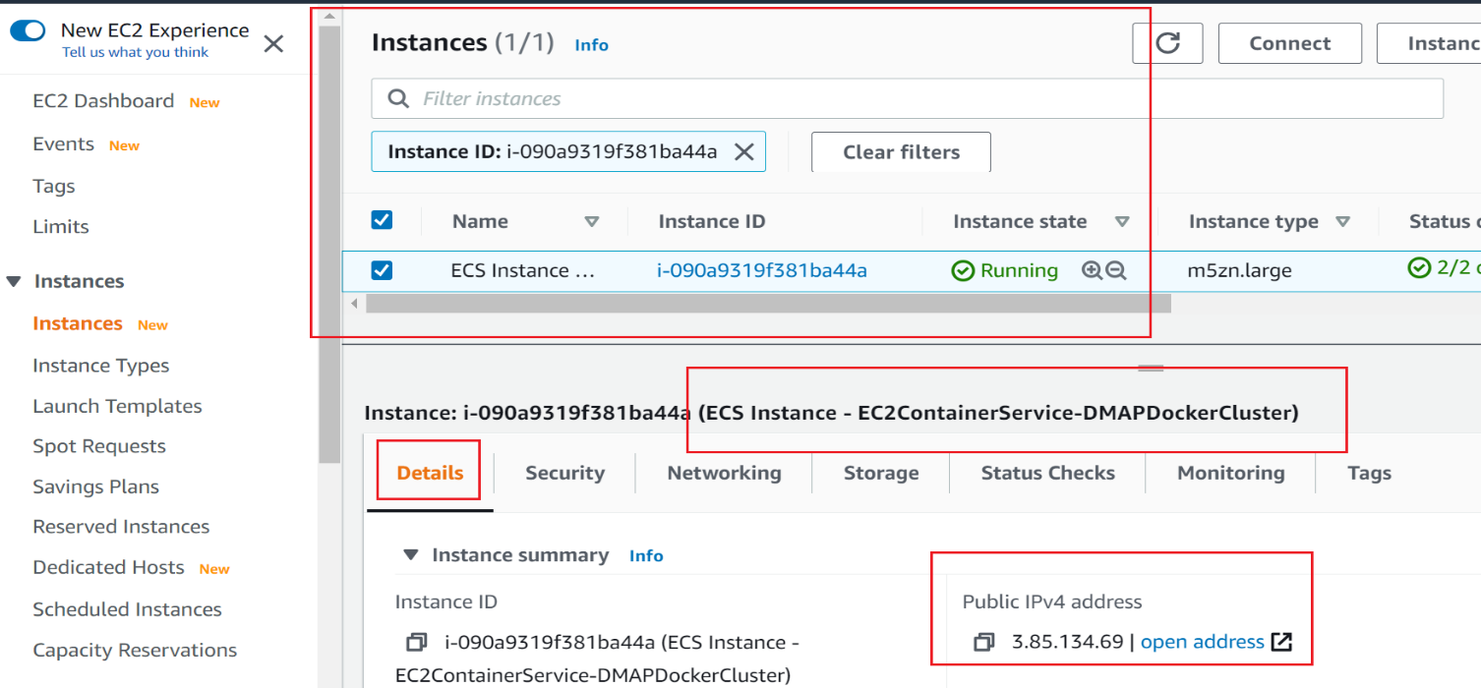
Note: Make sure that host machine security group is configured with inbound rules by enabling ports such as 8080 and 5002 to allow access from outside world. For that, select the security tab and click Security groups link as below.

Click on Security Groups to navigate to Security group details screen.

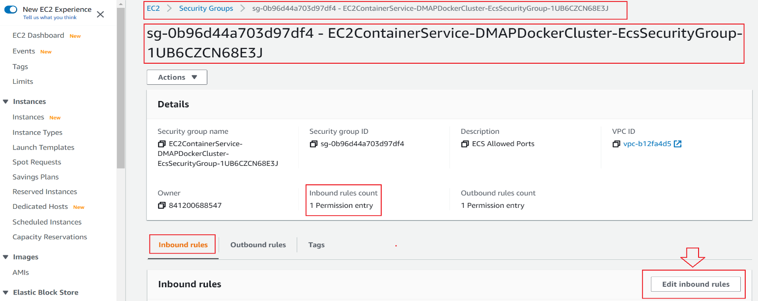

In the above screen, click on Edit inbound rules button to check or add new rules to allow DMAP required ports i.e., 8080 and 5002 to access from outside world.

After entering above details, click on Save rules button.

Now we are ready. Open Google Chrome web browser and enter below URL in web browser to access DMAP:

http://<<IP_ADDRESS>>:8080/DMAP

Enter username and password to login. If you do not have username and password setup yet, then refer APPENDIX to create user account and activate license.
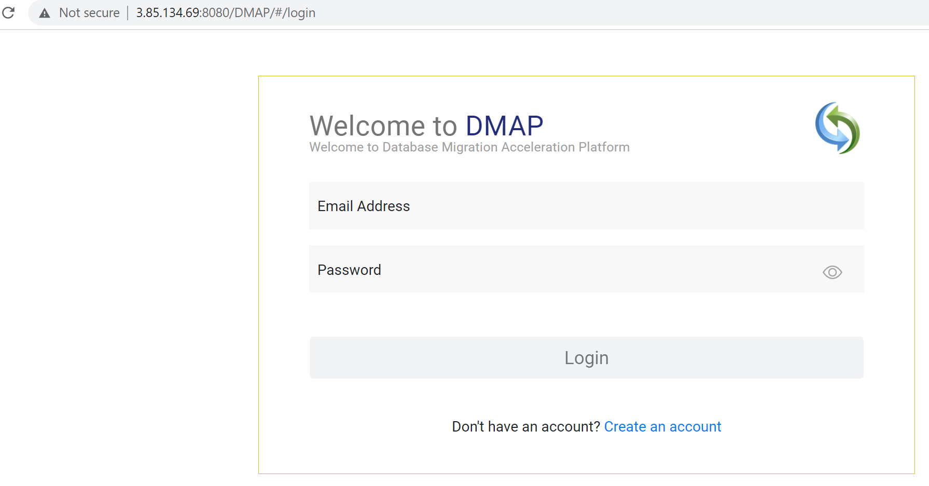

Creating Container in User’s Workstation

Installation Procedure
Follow below installation procedure to complete installation of DMAP.
- Download docker software from docker official website (based on your operating system) and install it, if not installed already.
- Download and install AWS CLI utility from https://aws.amazon.com/cli/ (based on your operating system), if not installed already.
- Have AWS account with full access to below services,
- Elastic Container Registry (ECR) to upload DMAP docker image
- Elastic Container Service (ECS) to create clusters, create Task definition and run Task
- EC2 to create virtual servers
- Have Access key ID and Secret access key associated with your AWS account for Programmatic access to AWS services to download DMAP Docker image from ECR using AWS CLI commands.
- Note: Before moving to next step, make sure AWS CLI is installed and is configured with access key and secret access key. If not, refer Appendix section AWS Configure to configure keys to access AWS services from the command prompt or terminal.
- To login into ECR, go to terminal or command prompt and type command as
aws ecr get-login-password --region <<??REGION??>> | docker login --username AWS --password-stdin <<??ACCOUNTID??>>.dkr.ecr. <<??REGION??>>.amazonaws.com
- <<??REGION??>> - region where repository is created
- <<??ACCOUNTID??>> - AWS account id. It can be retrieved from the console as below

Sample command:

aws ecr get-login-password --region us-east-1 | docker login --username AWS --password-stdin 841200688547.dkr.ecr.us-east-1.amazonaws.com

- Once successfully logged in, command prompt will show Login Succeeded message.

- After successfully logging into ECR, run the below to pull the DMAP docker image.

docker pull <<??image_name??>>:<<??tag??>>
  - <<??image_name??>> - name of the docker image (i.e. uploaded to ECR in section “Upload downloaded DMAP docker image into Elastic Container Registry (ECR))”
  - <<??tag??>> - tag name
- To check the image is pulled from docker registry, run the below command to view the list of all the downloaded images.
docker images
- To create a container and run the DMAP image in container for the first time, run the below command.
docker run -d -it -p 5002:5002 -p 8080:8080 --name=dmap_c <<??downloaded_docker_image_name??>>:<<??tag??>>
  - <<??downloaded_docker_image_name??>> - name of the downloaded docker image
  - <<??tag??>> - tag name
Above values can be retrieved by executing command docker images which lists downloaded docker images with details such as name, tag and so on.
- To start the DMAP container (if this is not the first time), run below command.
docker start dmap_c
- To stop the DMAP container (if this is not the first time), run below command. Please do not stop the container, if you are using the DMAP.
docker stop dmap_c
Note: dmap_c is the name of the container, you can give any name of your choice.
- When DMAP container is started, it will download fresh binary files for GUI and backend services for the first time. In subsequent runs, it checks if a newer version is available and downloads it from AWS S3 bucket. So, depending upon speed of your internet, please wait for 5 – 15 minutes for DMAP to download these files and then proceed to next step to open the login page.

Accessing DMAP
Login
Open Google Chrome web browser from your workstation. Next, enter below URL in web browser to access DMAP:
- http://localhost:8080/DMAP
Enter username and password to login. If you do not have username and password setup yet, then refer “APPENDIX” section to create user account and activate license.
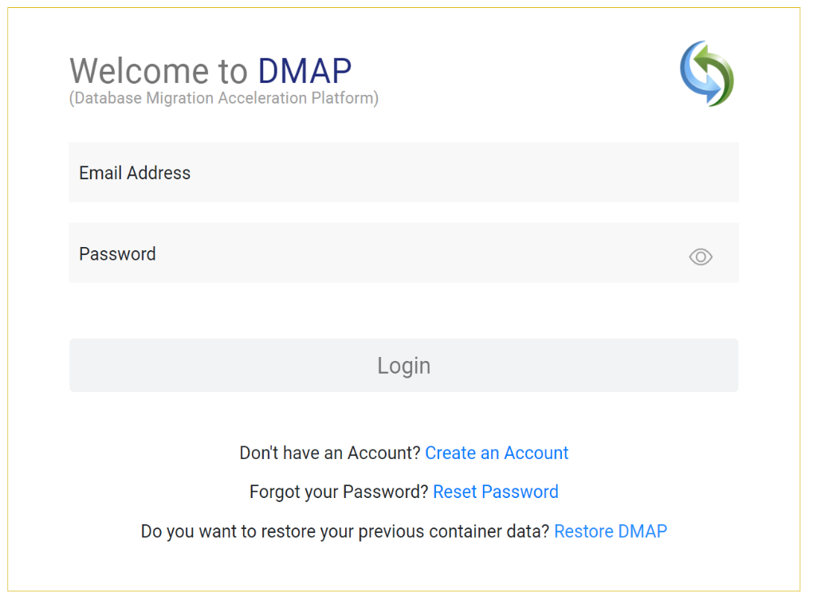

Support
For immediate assistance, please contact us on dmap_support@newtglobalcorp.com , dmapsupportgroup@newtglobacorp.com ; one of our technical team members will work with you to resolve your issue.

Appendix

Create Account
First time user is required to create a new account by clicking “Create an account” link on the Login page. Only one user account is allowed per DMAP container. For additional users (if license permits), please install and setup DMAP separately on their workstations.
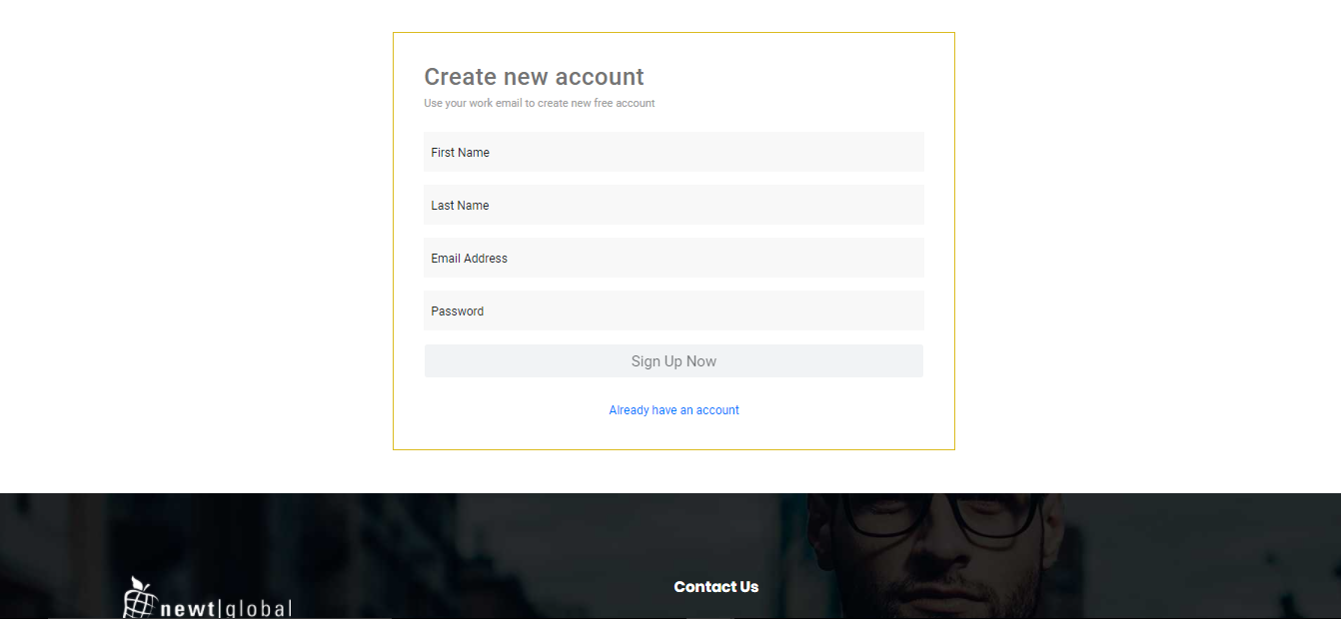
After signing up, enter the email id in the “Email Address” and password in the “Password” text box of login page. Ensure that email id is entered in a valid email format and click on “Login” button.
After successful login, user will be directing to buy license page. To buy a license or renew the license, you must contact DMAP sales team. DMAP sales team details will be shown on the license activation page. Or alternatively you can enter the license key of Trial license of DMAP if you have one.

Activate License
For the first time user, user needs to enter License key and accept the License Agreement.
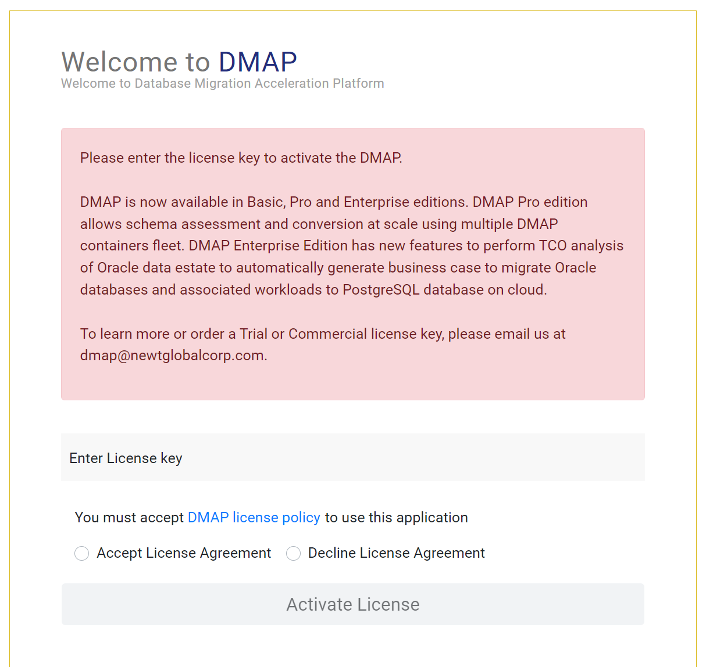

Note: Trial or Commercial license will be shared and explained by our sales team. You can contact our sales team on dmap@newtglobalcorp.com or visit our website (https://newtglobal.com/platform-enquiry) to request a quote or buy a license.

Next, click on “Activate License” button which will direct you to “Get Started with Migration” Page. To use DMAP, please refer to the “User Guide” provided to you.

AWS Configure
To access AWS services from local user machine using AWS CLI utility, we need to configure AWS credentials (one-time action) in the machine.
To check whether AWS CLI utility is installed or not, type aws in the terminal and press enter as shown below.

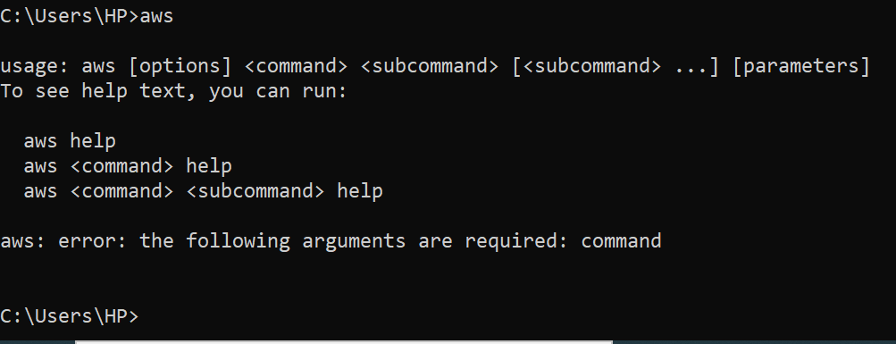

With the above message, we confirm that utility is installed in this machine. Next, type aws configure command and press enter. Now enter details on the prompt.
Enter your AWS Access Key ID and AWS Secret Access Key (provided by AWS administrator). For region, enter the default region you want to access through programmatically.

